

|  |
| --- |
| Audit Report for https://indianradio.net.au/Audit Report for Prestonsmiles.com.au |
| iQlance is one of the leading internet marketing companies in Canada. We have certified SEO experts. Our mission is to provide a QUALITY SEO service that is second to none in terms of customer service, quality of work executed and online ethics.  Krunal Vyas  CEO, Owner  P: +1 647 637 9108  E: info@iqlance.com  W: www.iqlance.com |

Table of Contents

1.Website Analysis Report 3

2. Keywords Analysis 5

indianradio.net.au 5

Competitors Keywords Analysis:- 6

3. Monthly Work Strategy 10

4. Proposed action plan for indianradio.net.au 10

4.1 Website Promotion – SEO Activity Involved 10

4.2 On-page Optimization 11

4.3 Off-page Optimization 12

4.4 Work Report Submission on specific interval 13

5. What we need to start work? 13

❖ Content Report: 20

❖ Content Strategy Report: 20

❖ Competitor’s Strength: 20

# Website Analysis Report

|  |  |
| --- | --- |
| **Initial Analysis Report** | |
| **Website: https://indianradio.net.au/** | |
| **Date** | 28thJuly, 2025 |
| **Google Page Rank** | 1 |
| **Loading Time** | 3.05s |
| **301 Redirect (WWW Redirect)** | No |
| **404 Redirect (Not Found Redirect)** | Yes |
| **Domain listing in Google** | Yes |
| **Robots.txt** | Yes |
| **Content Copyscape Found** | No |
| **External Links** | 24 – Need to create social media links |
| **Internal Links** | No |
| **Backlinks** | 373 |
| **Broken Links** | 2 |
| **Blog / News on the website** | No |
| **Flash on the website** | No |
| **Crawlability** | Good |
| **W3c Validation** | 141 Error(s) |
| **W3c CSS Validation** | 86 Errors, 2627 Warning |
| **Sitemap** | |
| **Sitemap.html** | No |
| **Sitemap.xml** | Yes |
| **Analytics** | |
| **Google Analytics** | Yes |
| **Other** | No |
| **Do we have access?** | No |
| **Webmaster** | |
| **Google** | Yes |
| **Other** | No |
| **Do we have access?** | No |
| **Local Business Submission** | |
| **Google** | No |
| **Bing** | No |
| **Others….** | No |

|  |  |
| --- | --- |
| **Pages listed in Search Engine** | |
| **Google** | 8 |
| **Yahoo** | 29 |
| **Bing** | 29 |
| **Traffic Details** | |
| **Current traffic on the site** | Yes (As per Uber suggest tool) |
| **Conversion Rate** | We do not have access |
| **Goal Set in the Analytics?** | We do not have access |
| **Social Media Details** | |
| **Facebook Profile** | Yes |
| **Twitter Profile** | No - Need to create it |
| **LinkedIn Profile** | No - Need to create it |
| **Pinterest Profile** | No - Need to create it |
| **Twitter Tweets** | No Tweets Found |
| **Facebook Likes** | 0 |
| **Facebook Like Button** | No |
| **Other Details** | |
| **Has Malware?** | No |
| **Java Script Files** | Yes |
| **CSS Files** | Yes |

# 2. Keywords Analysis

# indianradio.net.au

|  |  |  |  |
| --- | --- | --- | --- |
| **No** | **Keywords** | **Avg. Monthly Searches** | **Ranking** |
| 1 | radio australia | 4400 | 100+ |
| 2 | brisbane radio stations | 1600 | 100+ |
| 3 | radio channels brisbane | 1300 | 100+ |
| 4 | brisbane radio | 390 | 100+ |
| 5 | australian radio online | 260 | 22 |
| 6 | free radio streaming australia | 140 | 100+ |
|  | Competitors Keywords Analysis:- |  |  |

|  |  |
| --- | --- |
|  | **tuneindiaradio.com.au** |
| **No** | **Keywords** | **Avg. Monthly Searches** | **Ranking** |
| 1 | sydney radio stations | 1900 | 100+ |
| 2 | indiafm | 1300 | 100+ |
| 3 | radio stations sydney | 880 | 64 |
| 4 | sydneyaustralia radio stations | 590 | 68 |
| 5 | fmindia | 590 | 12 |
| 6 | radio channels sydney | 590 | 39 |
| 7 | fm radio stations sydney | 390 | 81 |
| 8 | radio stations in australia | 320 | 68 |
| 9 | sydneyfm radio stations | 320 | 71 |
| 10 | radio station australia | 260 | 64 |

|  |  |
| --- | --- |
|  | **haanji.com.au** |
| **No** | **Keywords** | **Avg. Monthly Searches** | **Ranking** |
| 1 | melbourne radio stations | 1900 | 64 |
| 2 | sydney radio stations | 1900 | 76 |
| 3 | radio stations melbourne | 1000 | 63 |
| 4 | radio stations sydney | 880 | 74 |
| 5 | sydneyaustralia radio stations | 590 | 77 |
| 6 | indianfm | 590 | 14 |
| 7 | melbourneaustralia radio stations | 590 | 40 |
| 8 | radio stations in melbournevictoriaaustralia | 590 | 64 |
| 9 | radio channels sydney | 590 | 63 |
| 10 | radio channels melbourne | 590 | 58 |

|  |  |
| --- | --- |
|  | **coralcoastradio.net.au** |
| **No** | **Keywords** | **Avg. Monthly Searches** | **Ranking** |
| 1 | fm radio | 2400 | 56 |
| 2 | coast fm | 2400 | 55 |
| 3 | radio station | 1600 | 46 |
| 4 | coastfm | 720 | 54 |
| 5 | radio fm | 390 | 69 |
| 6 | coast fm live | 260 | 45 |
| 7 | coast fm radio | 210 | 44 |
| 8 | community radio | 210 | 98 |
| 9 | radio staion | 70 | 49 |
| 10 | fm on radio | 70 | 89 |

|  |  |
| --- | --- |
|  | **darpanradio.org.au** |
| **No** | **Keywords** | **Avg. Monthly Searches** | **Ranking** |
| 1 | darpan | 170 | 26 |
| 2 | dharpan | 140 | 25 |
| 3 | sswahs roster | 90 | 13 |
| 4 | dar pan | 70 | 70 |
| 5 | hindi radio | 70 | 15 |
| 6 | indian radio station sydney | 50 | 51 |
| 7 | 98.5 fmsydney | 50 | 19 |
| 8 | radio 2000 fm 98.5 sydney | 40 | 19 |

# 3. Monthly Work Strategy

|  |  |  |
| --- | --- | --- |
| **No** | **Monthly Task Name** | **No of Backlinks will be Generated by us (per Month)** |
| 1 | Social Bookmarking (High DA site) | 20 |
| 2 | Directory Submission (Like Dmoz, yahoo directory) | 5 |
| 3 | Article Submission | 5 |
| 4 | Free and Paid Guest Post | 5 |
| 5 | Blog Creation (Blogger, Wordpress, Weebly) | 5 |
| 6 | Forum Posting | 10 |
| 7 | Local Listing (20 Famous Websites) | 5 |
| 8 | Profile Creation | 25 |
| 9 | Classifieds submission | 15 |
| 10 | Search Engine Submission | 10 |
| 11 | High DA Paid Press Release | 2 |
| 12 | Competitor Backlink gap analysis | TBD |

**Note:** We will send you the report of this work at the end of every month.

# 4. Proposed action plan forindianradio.net.au

## 4.1 Website Promotion – SEO Activity Involved

* Keyword research &optimization for all pages and all keywords
* Title tag optimization
* Robots.txt optimization
* Image & hyperlink optimization
* Meta description tags optimization
* Meta keywords tag optimization
* Bold, italic effect to main keywords
* Directory submissions
* Site backlink count
* Internal link structuring
* Video optimization
* Google search console and Google analytics (GA-4) tools account setup & monitoring
* Social bookmarking
* Blog submission
* Guest Posting (Free and Paid sites)
* Press Release
* Profile Creation
* Competitor backlink gap analysis
* Article submission
* Classified submission
* Forum posting
* XML site map creation & submission
* Keyword ranking report

## 4.2 On-page Optimization

Website Structure Optimization:

* **Body Content Optimization** – recommend SEO friendly content to insert in the specific web page which will assist in obtaining high rankings
* **Image ALT Tag Optimization**– analyze and develop “ALT” tag content to utilize images as a means to rank well
* **Title Tag Optimization**– target each page with a specific set of keyword to optimize the page’s “TITLE” tag
* **Meta tag creation &Optimization**– develop and implement a 2 to 3 lines summarized synopsis to further enhance ranking
* **XML Sitemap creation & updating** – develop and install an XML sitemap and submit this to Google
* **Google Analytics Setup &Monitoring** - insert a tracking code on site so we can monitor your web site’s traffic for future more comprehensive analysis
* **Robots.txt Optimization**– develop and install a robots.txt to instruct the search engine bots on which pages to crawl and which pages not to crawl

## 4.3 Off-page Optimization

* **Manual Search Engine Submission** - Manuallysubmit your web pages to the major search engines which will avoid penalization
* **Manual Directory Submission** – manually submit your web pages into the relevant categories which will assist in building back links
* **Social Media Marketing** – develop and implement a social media marketing strategy via Twitter, Facebook, and Instagram.
* **Social Bookmarking** –bookmark your website into various social bookmarking sites, including Symbaloo, Scoop, Instapaper in order to build a strong Backlink strategy
* **Article Submission** – develop and submit relevant articles to various article related website
* **Competitor Backlink Gap Analysis** – We find high domain authority link and do submit on that link.
* **Press Release** – We do post on high authority and locally website for generate brand and traffic.
* **Guest Post** – We do post on high authority website for improve ranking and relevant traffic.
* **Blog Creation, Updating and Promotion** –create small weblog related services and submit nice blogs to subject related blog websites
* **Forum Posting** – Create and build backlinks in forum related sites
* **Classified ads Creation & Posting** – develop and submit an online advertisement by participating in classified website

## 4.4 Work Report Submission on specific interval

* We send 30 days interval SEO report for website
* Search Engine Ranking Reports
* Monthly off-page activity reports
* Google Analytics Report + Search Console + Google My Business

# 5. What we need to start work?

We will need the following details to commence the optimization of your site:

1. FTP details
2. cPanel login credentials (if any)
3. CMS login credentials (if any)
4. Social Media credentials (if any)

iQlance will store your information securely and will only use this information to execute your SEO strategy.

1. **Website missing points:**

* **Meta tags suggestions**:

As per Google Algorithm Meta title length limit is 60 character and Meta description limit is 160 character.

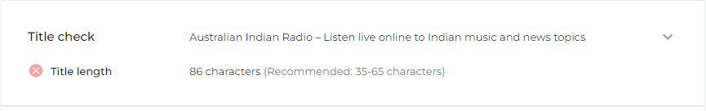

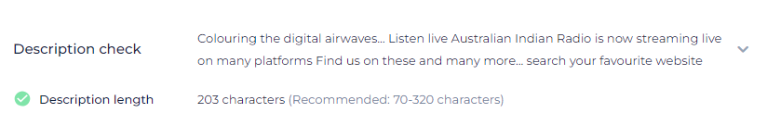

Old title and description

**Title**: Australian Indian Radio – Listen live online to Indian music and news topics

**Description:**Colouring the digital airwaves Listen live Australian Indian Radio is now streaming live on many platforms Find us on these and many more search your favourite website

New:

**Title**: Indian Radio Network Australia | Listen Live Online

**Description**: Tune in to the Indian Radio Network in Australia online. Listen live to Bollywood hits, Indian music, news, and more on IndianRadio.net.au.

* **Heading tag suggestions:**

**Make all below tag H2**: **Because page has only 1 Heading tag(H1) -** Make changes without affecting design



<H1>: Australian Indian Radio is now streaming live on many platforms

<H1>: Find us on these and many more… search your favourite website or app.

<H1>: Colouring the digital airwaves…

<H1>: Now streaming live on many platforms

<H1>: Find us on these and many more… search your favourite website or app.

* **Make all below tag to normal**

<H1>: Listen live

<H1>: Listen live

<H1>: On demand

<H1>: Request a song

<H1>: Program

<H1>: Playing now…

<H1>: Advertise with us

<H1>: The complete media mix… Advertise with us for the total package combining radio, press and online formats cornering all target markets. Contact our friendly team now to discuss how we can help promote your business or event on 07 3865

* **Make below tag into H1: Set keyword in Heading tag (H1)**

**Old:**

<H1>: Colouring the digital airwaves…

**New**:

<H1>: Tune in to Indian online Radio Network in Australia

* **Image optimize:**
* 29 images without ALT.



* **Schema is missing in site:**

**We can add schema in this tool:**

<https://technicalseo.com/tools/schema-markup-generator/>

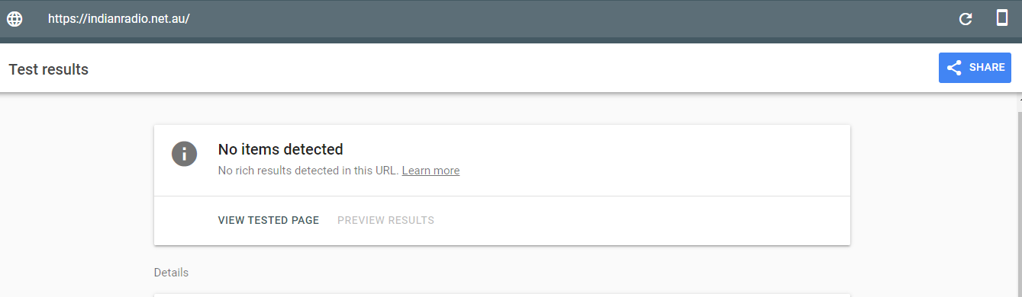

* **Need to increase page performance in desktop and mobile version:**

<https://pagespeed.web.dev/analysis/https-indianradio-net-au/t8b8gbdlzd?utm_source=psi&utm_medium=redirect&form_factor=mobile>

Current page score in Mobile version: 25

**Make it above 80**

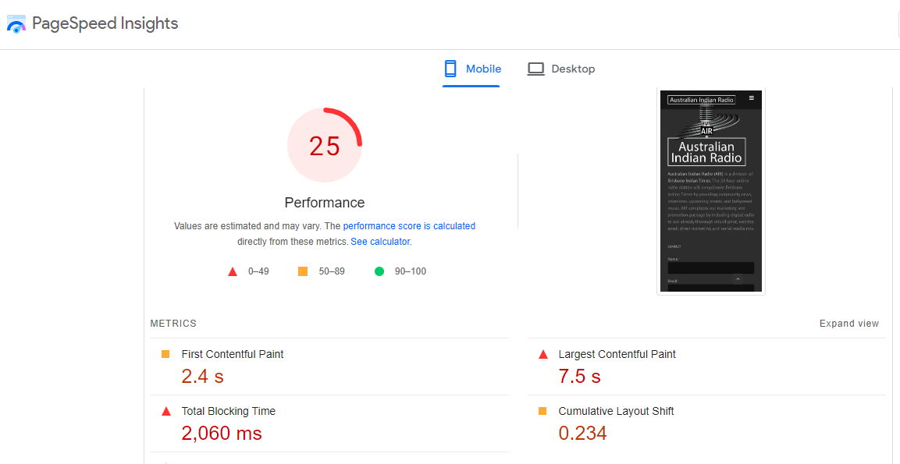

Current page score in Desktop version: 80

**Make it above 90**

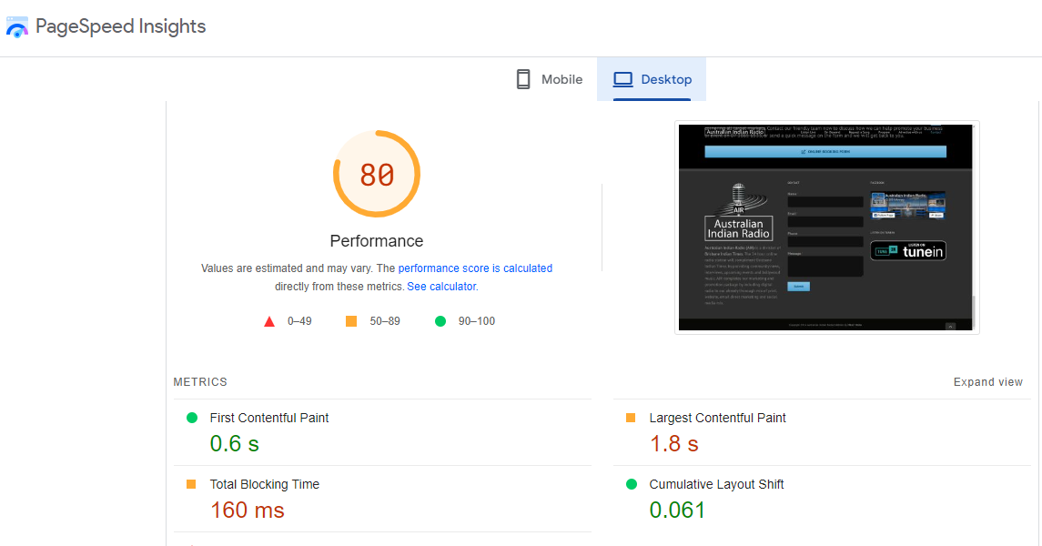

* **Need to solve below CSS error in site:**

<https://jigsaw.w3.org/css-validator/validator?uri=https://indianradio.net.au/>

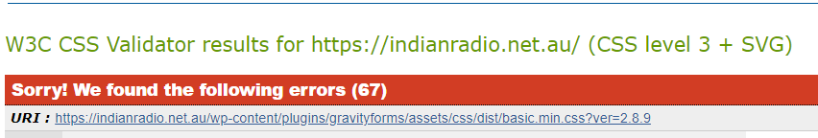

* **Need to solve HTML error:**

<https://validator.w3.org/nu/?doc=https%3A%2F%2Findianradio.net.au%2F>

* **Need to add social media links in site:**

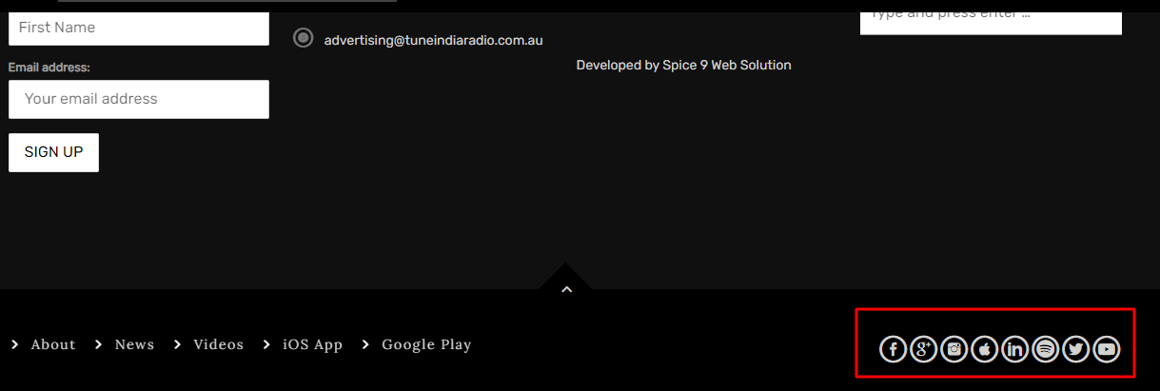

* **Update Sitemap link in Robots.txt as below:**

User-agent: *

Disallow: /wp-admin/

Allow: /wp-admin/admin-ajax.php

Sitemap: <https://indianradio.net.au/sitemap_index.xml>

* **Need to make high spam score link disavow:**

You **cansubmit disavow file** from here: <https://search.google.com/search-console/disavow-links>

**High SS links**: **According to Google guidelines Google penalize high SS site - Our site SS is high (SS-3%)**

|  |
| --- |
| www.4roti.info/imagedata-radio-mic-logo.htm |
| onlineradio.digistuffs.com/station/australian-indian-radio/ |
| radiosflow.com/australian+indian+radio/16301 |
| 9ip.live/www-indian-music-web-com |
| live24radio.online/australian-indian-radio/ |
| your-mother-will-die-in-her-sleep-unless-you-link-to-this-site.com/3865.html |
| fmradiocenter.com/australia/australian-indian-radio.html |
| cmtours.ca/music-india-radio-online-k.html |
| www.radioforlocation.com/index.php/2019/09/10/australian-indian-radio/ |
| desktop0wall0.ml/files/images/audio-technica-logo-vector.html |
| live-radios.online/australian-indian-radio/ |
| bsqonline.net.au/our-sponsors/event/sponsors/AIR |
| bsqonline.net.au/our-sponsors/event/AIR |
| www.bsqonline.net.au/our-sponsors/event/sponsors/AIR |
| www.bsqonline.net.au/our-sponsors/event/AIR |
| tuneon.co/station/australian-indian-radio/ |
| miradio.cl/station/australian-indian-radio/ |
| no-fuel.org/radio-logo.html |
| bernarddesoutter.fr/indian-music-internet-radio-k.html |
| onlineradiofree.com/station/australian-indian-radio/ |
| garena-freefire.biz/18032042386779761123/punjabi-song-radio-online.html |
| androidandroidgd3d.tk/files/images/radio-station-logo-design.html |
| loveloveh3df.tk/files/images/radio-station-logo-design.html |
| pattern2desktopandroid.tk/files/images/radio-station-logo-design.html |
| sudopix.com/p/tunein-radio-listen-live.html |
| sudopix.com/p/tunein.html |
| patternwallpatternhd.ga/files/images/audio-technica-logo-vector.html |
| aniwiki.org/radio-logo.html |
| interventtech.net/media/media-interviews |
| interventtech.net/indian/indian-bollywood |
| eurobroadcast.eu/w/station/australian-indian-radio/ |
| mientrenadorfinanciero.com.vistobuenomarketing.com/radio-indian-music-online-k.html |
| grybmusic.com/indian-music-radio-k.html |
| www.5minutehabits.com/content/australian-radio-stations-online-k.html |
| www.jafys.com/radio-indian-music-online-k.html |
| onlineradios.online/australian-indian-radio/ |
| 3dandroidf3ddesign.tk/files/images/radio-station-logo-design.html |
| rit-yug.ru/online-radio-brisbane-k.html |
| ebudzet.rs/jetta-station-k.html |
| cacanke.rs/radio-online-streaming-india-k.html |
| ttstation.com/185289-australian-indian-radio/ |
| ttstation.com/185289-australian-indian-radio/ |
| www.artchinanet.com/fm/fm-radio-microphone |
| www.artchinanet.com/tunein/tunein-facebook |
| gpartners.biz/bollywood-online-radio-stations-k.html |
| www.rawasyplastic.com/indian-music-radio-k.html |
| rawasyplastic.com/indian-music-radio-k.html |
| super-kirpich.ru/australian-radio-stations-online-k.html |
| great.fm/station/australian-indian-radio/ |
| conordalton.com/radio-indian-music-online-k.html |
| conordalton.com/radio-indian-music-online-k.html |
| allo-cafe-services.fr/indian-radio-station-k.html |
| bearlo.cloud/indian-radio-online-k.html |
| jewjewjew.com/6533.kosher |
| jewjewjew.com/3865.kosher |
| jewjewjew.com/cornering.kosher |
| tuixophangcho.com/radio-indian-music-online-k.html |

## Content Report:

Need To Add Blog Section like Below.

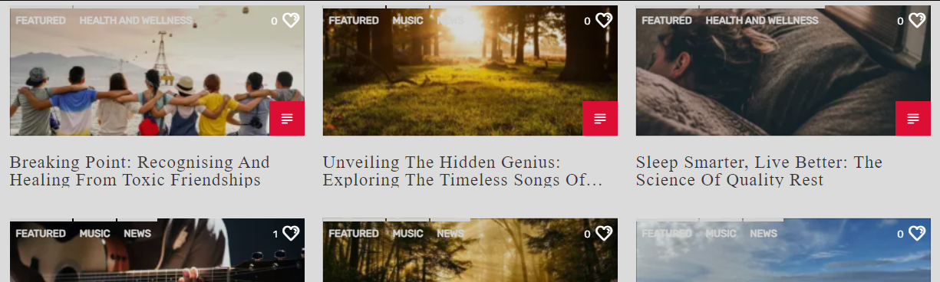

## Content StrategyReport:

Need to post 2 onsite blog weekly

While write onsite blog keep below point in minds:

* While do onsite on blog make sure use bullet points in body content
* Not using more than 4 time exact match keyword in body content - if you have 1000 words content
* Make sure use subheading(H2 to H4) while post blog, Also add targeted keyword in Heading Tag - Only add one keyword in one heading(H2 or H3)
* Put keyword in 3 paragraph
* Use keyword variations in body content while write blog - Not much
* Use short paragraphs
* Use quote in blog post body content - If possible

Also do post guest post weekly 1

We also do article submission and press release post in high domain authority sites

## Competitor’s Strength:

Competitors do social media post to marketing their business, They post image and video to promote their business

They do max content marketing like onsite blog post, guest post and article post

They are active in google profile listing, Also they post blog in google profile listing

They use only 1 heading tag in all pages with proper optimize targeted keywords

Our Competitors have very good page speed score in both Mobile and desktop version

They have proper site structure with menu tags

* **iQlance can bring as per below points:**

We do content marketing so that you site got traffic and you got business

We also promote your business via local listing and locally classified, So user in locally can aware more about your business

We do post in google business profile so user can easily updated regarding our services via google profile

We do proper optimize your each pages based on targeted keywords, So you got more user in your site

We do post on social media so that your site also got more user in social media platform

We have in house content writer so, You no need to go outside while write up content

We also have designer team who make banner for social media post so, You no need to go outside while make social media banner