# **How a Dating App Development Company Drives User Engagement**

In today’s competitive market, dating apps are no longer just platforms for meeting new people—they are dynamic ecosystems that thrive on user engagement. For startups and businesses entering this space, understanding how a **dating app development company** can help keep users active and invested is critical. From smart design choices to innovative features, the right development partner ensures your app stands out, fosters interaction, and retains its audience for the long haul.

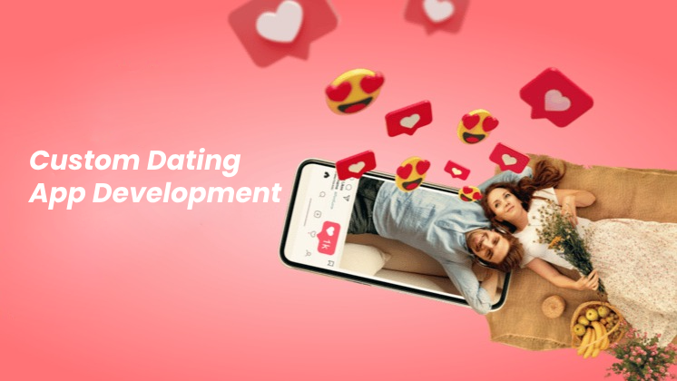

## **Understanding the Core of User Engagement**

User engagement isn’t just about attracting downloads; it’s about encouraging regular interaction and meaningful connections. A [dating app development company](https://sciencemission.com/preview/how-a-dating-app-development-company-shapes-modern-relationships) focuses on crafting intuitive interfaces, seamless navigation, and personalized experiences that make users feel valued. The goal is to create an emotional connection between the app and its audience.

## **Role of Skilled Developers in Engagement Strategy**

The importance of working with experienced professionals cannot be overstated. Whether you’re collaborating with a [skilled dating app developer](https://topicterritory.com/why-hiring-a-skilled-dating-app-developer-matters-for-your-project/) or a full-scale development firm, their insights shape every engagement-driving feature. From real-time chat systems to AI-powered matchmaking, these experts know how to balance innovation with user needs.

## **Personalization: The Key to Long-Term Usage**

Personalized experiences play a huge role in keeping users engaged. Companies specializing in [dating mobile app development](https://relxnn.com/dating-mobile-app-development-a-complete-guide-for-entrepreneurs/) leverage user data to offer customized matches, content suggestions, and tailored notifications. This not only enhances satisfaction but also increases the likelihood of repeat usage.

## **Integrating Modern Features That Users Love**

Modern dating apps are evolving beyond basic swiping. Today’s users expect video profiles, live streaming, voice prompts, and safety features. Insights from [industry experts](https://ideaepic.com/dating-app-developer-insights-building-apps-that-users-love/) show that incorporating features like AI-driven recommendations and advanced search filters dramatically improves engagement.

## **Supporting Startups with Scalable Solutions**

A growth-focused startup needs more than just an app—it needs a roadmap for scalability. Partnering with a [company offering essential dating app development services](https://ideaexpress.us/essential-dating-app-development-services-for-growth-focused-startups/) ensures your platform is built to handle increasing user numbers without compromising performance. Scalable infrastructure keeps the experience smooth, even during rapid growth phases.

## **Marketing Meets Technology**

No matter how great your app is, engagement requires visibility. That’s where a well-coordinated approach comes into play. A [custom dating mobile app development strategy](https://trendburst.us/custom-dating-mobile-app-development-for-the-modern-market/) integrates marketing-friendly features like referral programs, social sharing, and gamified rewards. These elements not only attract new users but also encourage current ones to keep coming back.

## **Enhancing User Trust and Safety**

Trust is at the core of engagement. Implementing advanced verification systems, AI-driven content moderation, and user-controlled privacy settings is standard for any [modern dating app development project](https://trendtracker.us/the-secrets-behind-successful-dating-mobile-app-development/). By making users feel safe, you create an environment where interaction flourishes.

## **From Vision to Reality**

The journey from concept to launch requires a reliable team that can bring your idea to life. For entrepreneurs, finding the right [dating app development company](https://allventurehub.com/how-to-find-the-best-dating-app-development-company-for-your-needs/) or [developer](https://bcrelx.com/choosing-the-right-dating-app-developer-for-your-vision/) means choosing someone who understands both the technical and emotional aspects of engagement. They must translate your vision into an experience that users love and return to daily.

## 

## **Real Results Through Expert Services**

The most successful apps are built by teams that understand how to deliver measurable results. That’s why many startups choose partners who specialize in [results-driven dating app development services](https://inspirejournal.xyz/dating-app-development-services-that-deliver-real-results/). Whether the goal is boosting daily active users or increasing subscription conversions, the right strategies make all the difference.

## **The Competitive Edge in a Crowded Market**

Standing out in a saturated dating app market is no small feat. Collaborating with a [company that supports startup success](https://nichenest.xyz/the-role-of-a-dating-app-development-company-in-your-startup-success/) ensures you have the right tools to compete. From unique branding to cutting-edge tech integrations, your app becomes more than just another download—it becomes a must-have platform.

## **Final Thoughts**

User engagement is the lifeblood of any dating app. By working with an experienced **dating app development company**, startups can build platforms that users not only download but also use, love, and recommend. With the right combination of personalization, safety, innovation, and scalability, your app can thrive in today’s fast-paced digital dating world.

If you’re ready to turn your idea into an engaging platform, explore proven approaches like those discussed in [this complete guide](https://nichebase.xyz/from-idea-to-reality-dating-mobile-app-development-explained/) and take inspiration from industry leaders. Your journey to building a high-engagement dating app starts with the right development partner.