Hire Expert Mobile App Developers in London for Custom App Solutions
In today’s digital-first world, mobile apps have become the foundation for business growth, customer engagement, and innovation. Whether you’re a startup launching your first product or an enterprise scaling your digital presence, hiring expert app developers in London can transform your business vision into reality. London’s thriving tech ecosystem is filled with talented professionals and agencies that deliver high-quality, scalable, and customized app solutions.
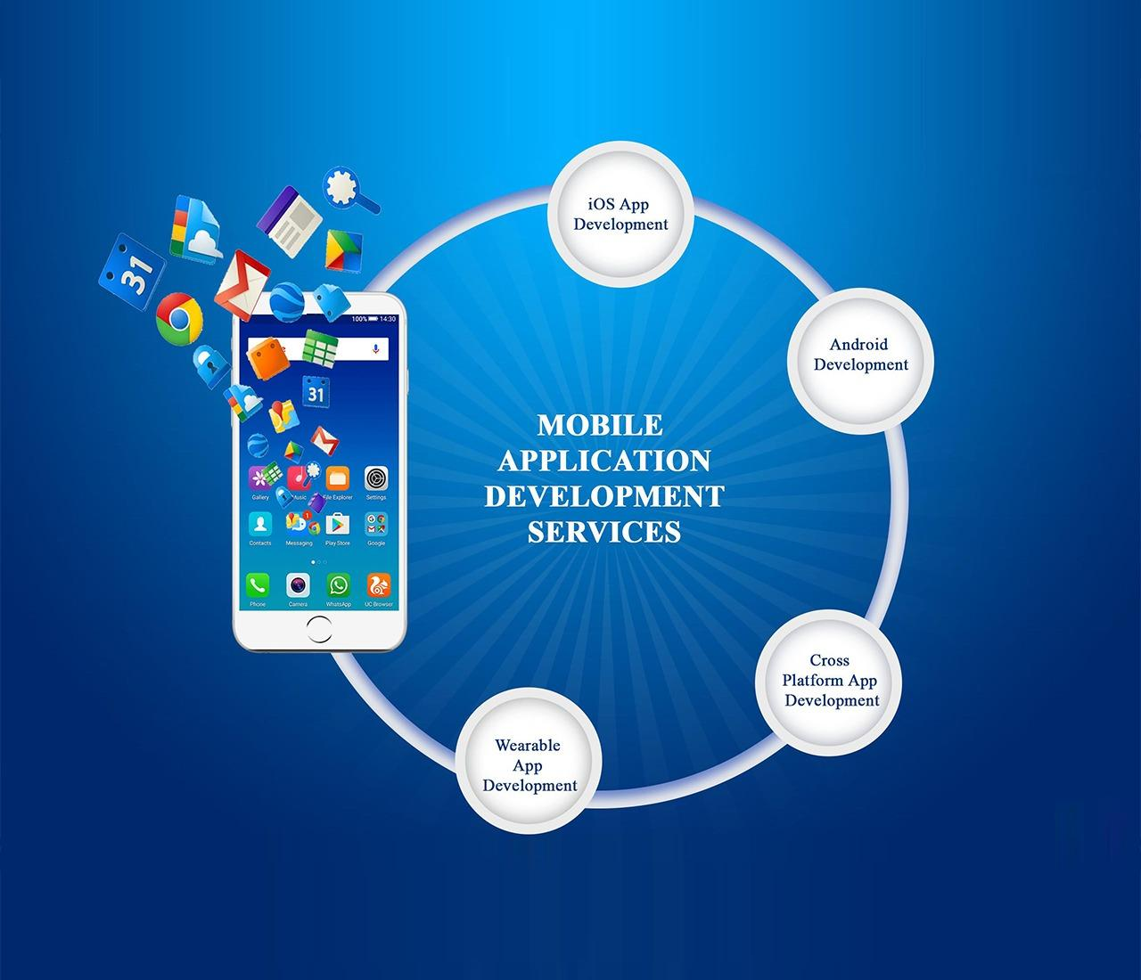
Partnering with an experienced app development company in London ensures that your mobile application is built with precision, innovation, and a focus on user experience. These developers combine technical skills with strategic insight to deliver mobile apps that not only perform well but also enhance your brand’s visibility and engagement. From ideation to deployment, London app developers are known for delivering exceptional results that meet business goals and exceed user expectations.
Businesses across industries are realizing the value of hiring an experienced app developer London to stay competitive in a digital world. With a strong understanding of modern technology trends, these experts craft applications that are robust, secure, and designed for future scalability. Whether it’s iOS, Android, or cross-platform development, mobile app development company in London professionals ensure each solution aligns perfectly with the brand’s objectives.
As mobile usage continues to rise, the demand for skilled mobile app developers London is growing rapidly. These professionals leverage the latest technologies such as artificial intelligence, blockchain, IoT, and AR/VR to create apps that deliver seamless experiences. With support from a reputable mobile app development company London, businesses can achieve operational efficiency and customer satisfaction while boosting their digital presence.
The process of app development London is more than just coding; it’s about understanding user behavior and creating intuitive solutions that meet their needs. A dedicated app development agency London follows a user-centric approach, ensuring every aspect of the app—from design to performance—is optimized for engagement and retention. This commitment to quality and innovation makes London mobile app developers among the most sought-after professionals globally.
If you’re planning to bring your business idea to life, App Development in London offers a wealth of opportunities. London’s dynamic market and skilled workforce provide businesses with everything they need to succeed in the digital age. Collaborating with a top mobile app development company in London ensures your app stands out with superior design, performance, and reliability.
At India App Developer, we specialize in creating high-performance mobile applications tailored to your unique business needs. As a trusted name in mobile app development London, we bring together a team of experts who focus on delivering end-to-end digital solutions. Our London app developers work closely with clients to design, develop, and deploy apps that drive engagement and growth. We use agile methodologies to ensure transparency, flexibility, and fast turnaround times, helping your business stay ahead of the competition.
Our proven experience as a mobile app development company in London enables us to deliver solutions that combine innovation and functionality. We understand that every business has unique goals, and our customized approach ensures your app resonates with your audience. From startup prototypes to enterprise-grade mobile platforms, our app developers London UK are equipped to deliver excellence across all stages of development.
In conclusion, hiring expert mobile app developers in London is a strategic decision that can elevate your business to the next level. With cutting-edge technologies, creative design, and a customer-focused mindset, London remains one of the best destinations for app development worldwide. If you want to transform your business idea into a high-performing digital product, partner with India App Developer, a trusted app development company in London, and experience the difference innovation can make.

