Jirawala Pipe & Tube – Your Trusted Round Bar Supplier in Saudi | Premium Quality for Every Industry
When it comes to industrial strength, durability, and performance, choosing the right Round Bar Supplier in Saudi can make a significant difference in your project’s success. Whether you’re in construction, oil & gas, fabrication, machinery manufacturing, or heavy engineering, high-quality round bars are a core requirement—and selecting a reliable supplier is essential.
If you’re looking for premium stainless steel, carbon steel, and alloy steel round bars backed by trust, consistency, and professionalism, Jirawala Pipe & Tube stands out as one of the most dependable names in the global metals industry. With a wide stock range, strong supply capabilities, and export-ready quality, we ensure that our clients across Saudi Arabia receive only the best.
👉 Explore our full range: https://www.jirawalapipe.com/round-bars.php


Why Round Bars Are Essential Across Industries
Round bars are one of the most widely used industrial materials due to their versatility and strength. They play a crucial role in:
- Construction
- Petrochemical and refinery plants
- Oil & gas drilling
- Marine engineering
- Automotive components
- Fabrication and machining
- Manufacturing shafts, fasteners, valves, and tools
This is why choosing an experienced Round Bar Supplier in Saudi like Jirawala Pipe & Tube becomes a key advantage for businesses aiming for reliability and long-term value.

Jirawala Pipe & Tube – Leading Round Bar Supplier in Saudi
Jirawala Pipe & Tube is a globally trusted exporter and stockholder of premium industrial metals. With a strong presence in the Middle East market, we supply high-grade stainless steel, carbon steel, alloy steel, and nickel alloy round bars to Saudi Arabia’s booming industries.
Our products are known for:
✔ International quality standards
✔ Dimensional accuracy
✔ Excellent mechanical properties
✔ Corrosion and heat resistance
✔ Wide size availability
✔ Competitive prices
✔ On-time delivery
We supply materials that meet ASTM, ASME, DIN, EN, and international engineering standards—ensuring that our clients never compromise on quality.
👉 Check product details: https://www.jirawalapipe.com/round-bars.php

Why Jirawala Pipe & Tube Is the Preferred Round Bar Supplier in Saudi
Here’s what makes us different from other suppliers:

1. Wide Range of Round Bar Materials
We supply round bars in multiple grades and materials to suit different industries:

Stainless Steel Round Bars
Ideal for high corrosion resistance and durability.
Grades include: SS 304, 316, 316L, 310, 321, 410, 420

Carbon Steel Round Bars
Perfect for construction, machining, and structural applications.
Grades include: ASTM A105, A350 LF2, AISI 1045

Alloy Steel Round Bars
High strength and heat-resistant bars for heavy engineering.
Grades include: AISI 4140, 4130, EN19, EN24

Nickel Alloy Round Bars
Used in petrochemical, desalination, and marine environments.
Grades: Inconel, Monel, Hastelloy
This makes Jirawala Pipe & Tube a complete, one-stop solution for all round bar requirements in Saudi Arabia.
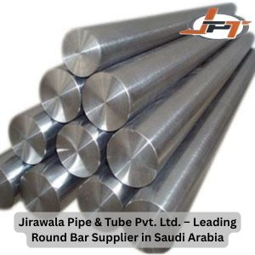

2. Perfect for Saudi Arabia’s Harsh Industrial Conditions
Saudi industries operate in environments with high temperatures, desert conditions, and corrosive atmospheres. Our round bars are engineered to handle:
- Heat
- Pressure
- Saltwater exposure
- Oxidation
- Abrasion
This ensures long service life and enhanced performance in tough conditions.
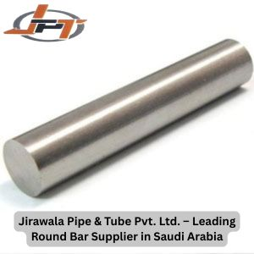

3. Ready Stock & Fast Delivery
We maintain a large inventory of round bars in multiple sizes, thicknesses, and grades. This allows us to offer:
- Quick dispatch
- Large volume supply
- Custom size availability
- Reliable export packaging
Businesses in Saudi prefer Jirawala Pipe & Tube because we deliver on time, every time.
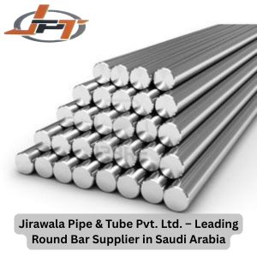

4. Custom Cutting & Export Packaging
Every client has unique requirements. We offer:
- Custom length cuts
- Export-grade wooden box packaging
- Heat treatment on request
- MTC (Material Test Certificates)
- Third-party inspection
This makes us one of the most professional Round Bar Suppliers in Saudi for industries that need precision and reliability.
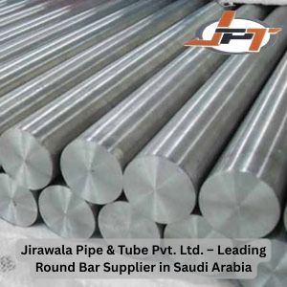

5. Transparent Pricing & Genuine Quality
We believe in fair pricing and maintaining long-term relationships. With us, you can expect:
- Competitive and transparent rates
- Zero compromises on quality
- Genuine materials with certification
- Customer-first approach
Our honest work ethic has helped us earn trust globally.

Industries in Saudi That Trust Our Round Bars
Saudi Arabia’s industrial sector is growing rapidly, and Jirawala Pipe & Tube proudly supplies round bars to:
- Oil & Gas Industry
- Petrochemical Refineries
- Construction & Infrastructure
- Water Treatment Plants
- Marine Engineering
- Power & Energy
- Industrial Machinery Manufacturing
- Fabrication Workshops
- Automotive Components
Our materials help industries build efficient systems, strong structures, and reliable components.

How to Choose the Right Round Bar Supplier in Saudi
When selecting a supplier, keep these factors in mind:

✔ Material Quality
Look for suppliers offering certified, tested materials.

✔ Experience
Years of experience matter when accuracy and reliability are critical.

✔ Stock Availability
The supplier should have a diverse and ready inventory.

✔ Export Capability
Professional packaging, timely dispatch, and proper documentation are essential.

✔ Customer Support
The supplier must respond quickly and guide you with the right grade selection.
Jirawala Pipe & Tube checks all these boxes—and more.

Benefits of Choosing Jirawala Pipe & Tube
You get:
- High-grade materials
- Custom dimensions
- Smooth surface finish
- Excellent machining properties
- Long-term durability
- Fast logistics support
- Export-quality packaging
- Competitive pricing
Our focus is not just supplying round bars - it is building trust and delivering real value to our clients in Saudi Arabia.

Why Businesses Prefer Indian Suppliers for Saudi Arabia
India has become a major supplier of metals and industrial materials to the Middle East because:
- Indian steel is globally trusted
- Superior quality at competitive pricing
- Strong manufacturing capability
- Expertise in export
- Fast delivery routes to Saudi Arabia
This makes Jirawala Pipe & Tube, a globally recognized Indian supplier, a perfect partner for Saudi clients.

Final Thoughts – Your Reliable Round Bar Supplier in Saudi
When your project demands accuracy, strength, and dependable quality, choosing the right Round Bar Supplier in Saudi becomes absolutely essential. With its commitment to excellence, wide product range, and trusted export service, Jirawala Pipe & Tube has established itself as a preferred supplier for industries across Saudi Arabia.
Whether you need stainless steel, carbon steel, alloy steel, or nickel alloy round bars—we deliver materials that fully meet international standards and withstand Saudi’s toughest industrial conditions.
👉 Explore our full range:
https://www.jirawalapipe.com/round-bars.php

