Jagtap Miniature – The Most Trusted Industrial Model Making Company in India | Transforming Ideas Into Realistic Scale Models
In today’s fast-evolving industrial world, visual communication is everything. Whether you’re presenting a new factory layout, demonstrating plant operations, showcasing machinery workflow, or explaining an engineering process - a physical scale model immediately creates clarity and impact. That’s where choosing the right Industrial Model Making Company becomes essential.
If you’re searching for a professional, reliable, and highly skilled team to bring your industrial concepts to life, Jagtap Miniature stands out as one of India’s leading names in precision model making. With years of experience, advanced craftsmanship, and a portfolio of complex industrial models, we help businesses turn technical plans into visually stunning and fully functional models.
👉Explore our full services: https://jagtapminiature.com/our-service.html


Why Businesses Need an Industrial Model Making Company
Industrial projects often involve large-scale infrastructures, intricate machinery, and technical processes. Explaining these details only through drawings or presentations can be challenging. A high-quality industrial model solves this by:

1. Enhancing Clarity
A scale model simplifies complex processes and gives your audience a clear understanding—whether it’s for training, presentations, tenders, or exhibitions.

2. Increasing Engagement
People naturally pay more attention to physical models. They create curiosity, excitement, and interest—making your project stand out instantly.

3. Better Decision-Making
Models help engineering teams analyse layouts, workflows, spatial arrangements, and safety considerations before construction begins.

4. Powerful Marketing Tool
Industrial models attract attention at trade shows, investor meetings, conferences, and client presentations, helping you communicate value at a glance.

5. Cost Saving in the Long Run
By identifying issues early through visual representation, companies avoid costly errors during construction or implementation.
This is why choosing the right Industrial Model Making Company is crucial—and why Jagtap Miniature remains a trusted partner for industries across India.

Jagtap Miniature – India’s Leading Industrial Model Making Company
Jagtap Miniature is widely recognized for creating high-precision industrial, engineering, architectural, and plant models tailored to unique business needs. Our work spans multiple sectors including manufacturing, real estate, energy, engineering, chemical plants, construction, and more.
With the perfect combination of experience, craftsmanship, and advanced technology, we deliver models that are:
✔ Highly detailed
✔ Durable and long-lasting
✔ Accurate to scale
✔ Visually impressive
✔ Custom-built for specific use cases
Our goal is simple: to transform your project into a compelling, realistic model that delivers impact and clarity from the very first glance.
👉 See our full offerings here: https://jagtapminiature.com/our-service.html

What Makes Jagtap Miniature the Best Industrial Model Making Company in India?
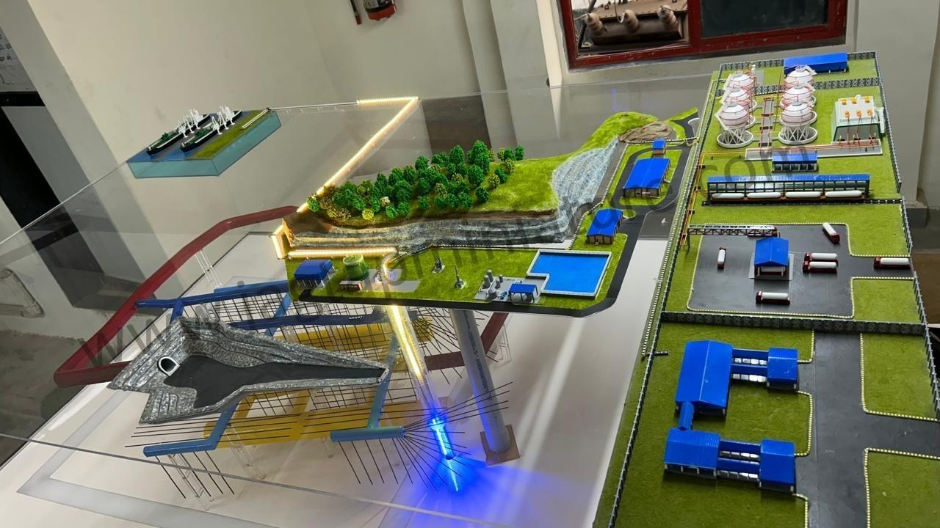
Choosing Jagtap Miniature means working with a team dedicated to precision, creativity, and customer satisfaction. Here’s what sets us apart:

1. Expertise in Industrial and Engineering Models
We specialize in creating models for industries such as:
- Manufacturing plants
- Power plants
- Chemical processing units
- Machinery layouts
- Engineering process models
- Automation systems
- Factory production lines
Whether you're presenting a new plant design or demonstrating a technical workflow, our models provide clarity and visual appeal.

2. High-End Craftsmanship and Detailing
Every model is carefully handcrafted with precision materials, ensuring:
- Clean finishing
- Realistic components
- Accurate proportions
- Detailed textures and elements
We use advanced tools, laser cutting, and modelling software to maintain professional accuracy.

3. Fully Customised Models Based on Your Needs
No two industries are the same—and neither are their scale model requirements. We customise:
- Scale
- Design
- Layout
- Materials
- Lighting
- Moving parts
- Interactive features
From simple display models to fully functional mechanical models, we create exactly what your project demands.

4. Perfect for Exhibitions, Presentations & Corporate Showcases
Jagtap Miniature models are widely used for:
- Trade fairs
- Buyer meetings
- Project demonstrations
- Tender presentations
- Investor pitches
- Safety training
- Museum exhibits
A physical model instantly elevates your presentation, making it memorable and easy to understand.

Types of Industrial Models We Create at Jagtap Miniature
We offer a wide range of custom industrial models, including:

1. Industrial Plant Models
Ideal for showcasing factory layouts, operations, and internal processes.
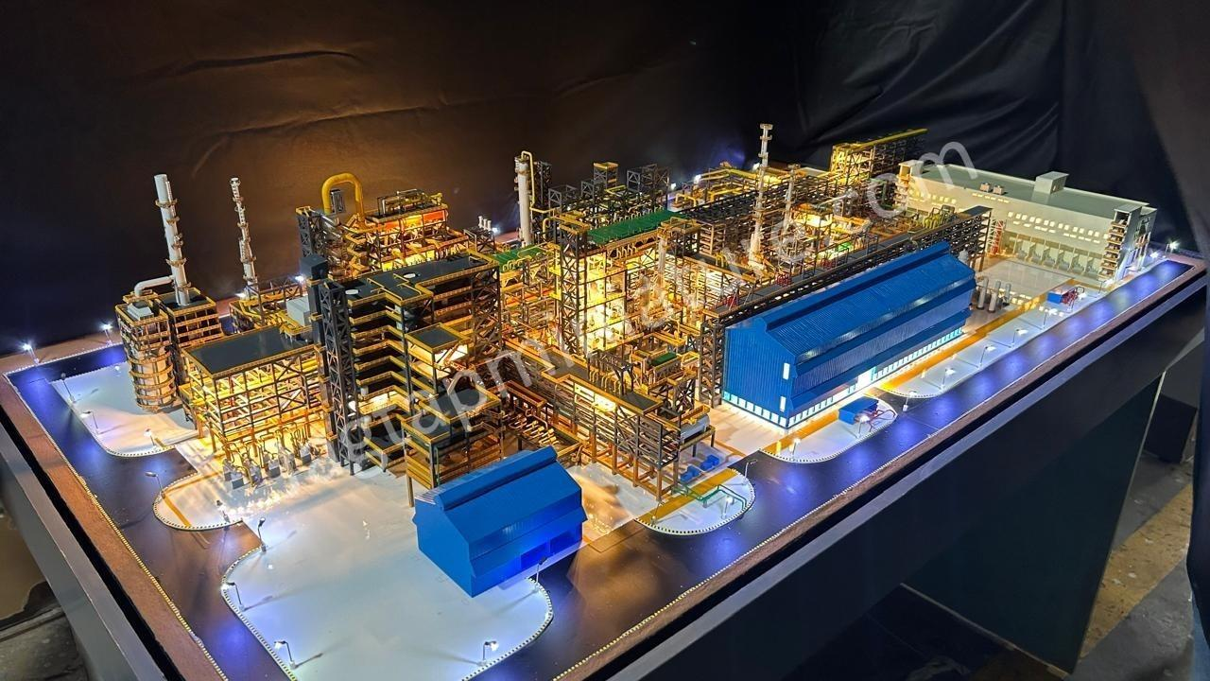

2. Machinery & Equipment Models
Accurate replicas of heavy machinery, equipment, and technical systems.
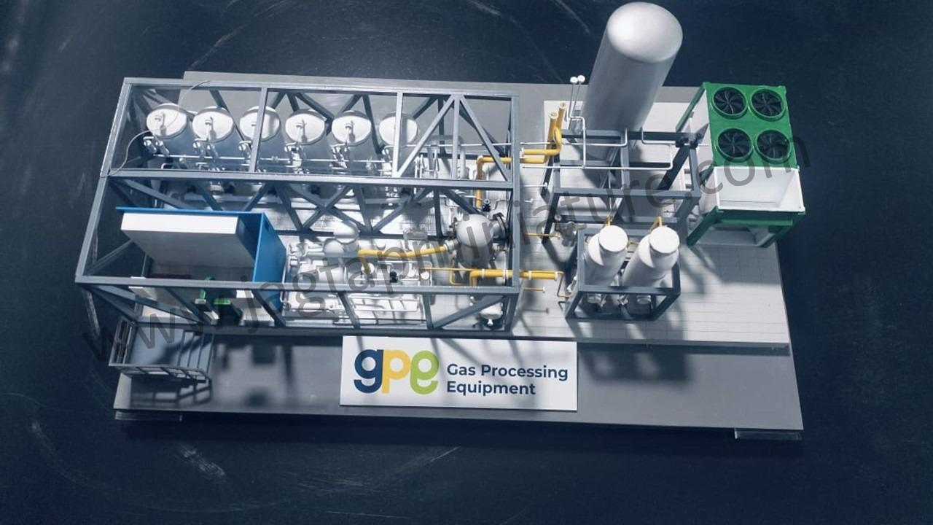

3. Engineering Process Models
Used to explain complex workflows, chemical processes, automation systems, and mechanical cycles.
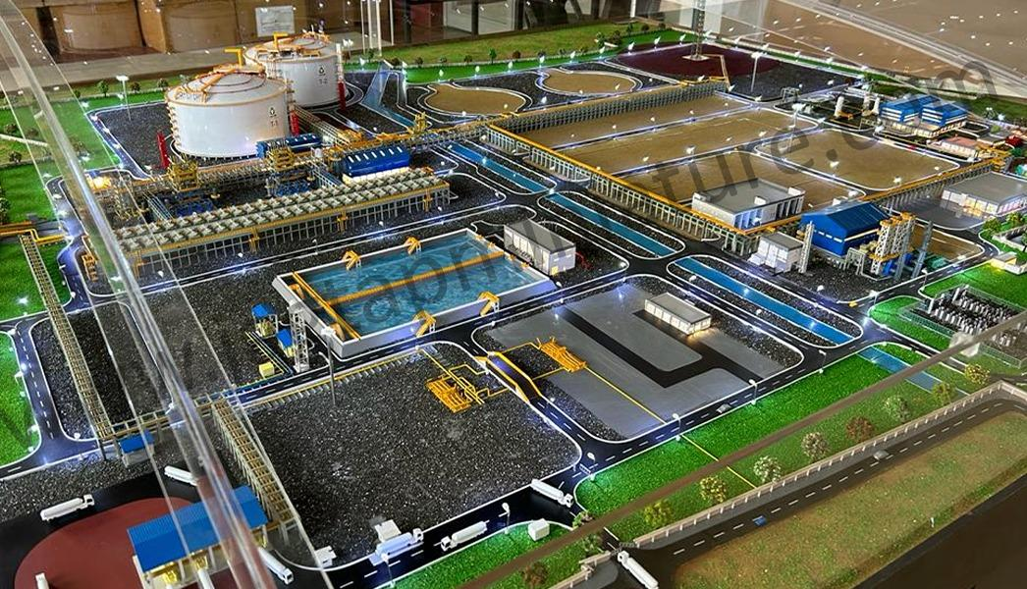

4. Prototype Models
Perfect for R&D, product development, and concept showcases.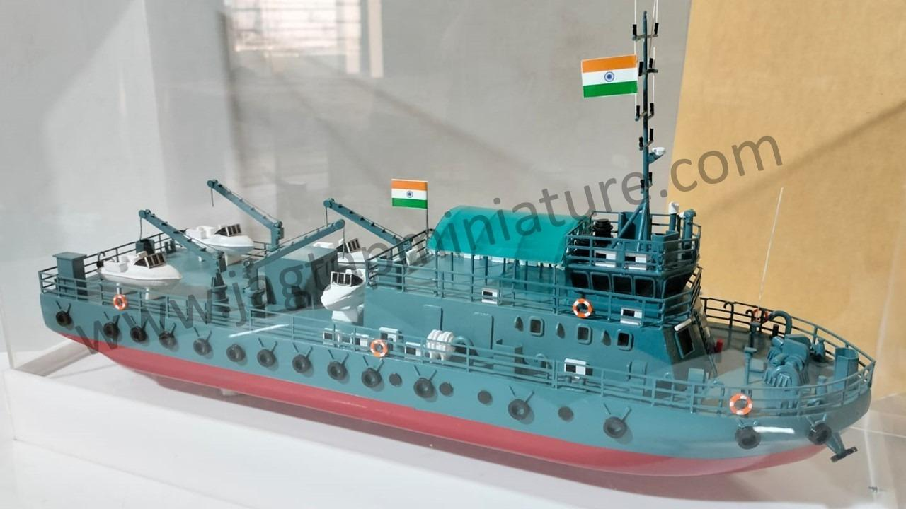

5. Interactive & Animated Models
Models with moving components, lighting, or digital integration for high-impact presentations.

Why You Should Choose Jagtap Miniature for Your Next Industrial Model
Here’s why companies across India trust us:
✔ Realistic and visually rich models
✔ Technical accuracy
✔ Fully customised solutions
✔ Professional finishing
✔ Quick turnaround time
✔ Affordable and transparent pricing
✔ Dedicated support and communication
When you partner with Jagtap Miniature, you're choosing a team that genuinely cares about your project’s success.

How Industrial Models Help Your Business Grow
A high-quality industrial model does more than just look impressive—it helps you communicate better, win more clients, and improve planning efficiency.

They Help You Win Tenders
Clients and investors trust what they can see. A physical model builds confidence instantly.

They Simplify Technical Explanations
Especially useful for industries with complex processes.

They Improve Brand Image
Companies with professional models stand out in exhibitions and trade shows.

They Support Employee Training
Easy for workers to understand systems, safety flows, and structure.

They Boost Customer Engagement
People prefer models over long presentations or digital slides.

Industries We Serve:
Jagtap Miniature proudly supports a wide range of industries:
- Oil & Gas
- Manufacturing
- Automobile
- Energy & Power
- Chemical Plants
- Water Treatment
- Mining
- Infrastructure
- Engineering Services
- Technology & Automation
Our models are used to highlight technical strengths, explain solutions, and communicate design value.

Final Thoughts – Choose the Right Industrial Model Making Company for Maximum Impact
Finding the right Industrial Model Making Company can make or break your presentation impact. With Jagtap Miniature, you get experience, precision, and creativity—all in one place. Our models help you communicate ideas better, attract investors, train teams, and win customer trust.
If you’re planning an exhibition, a major project presentation, or a new industrial setup, a professional model will give your project the extra edge it needs.
👉 Explore our services and previous work:
https://jagtapminiature.com/our-service.html

