HDPE Sheets Manufacturers in India with ISO-Certified Quality Standards | Polestar Polymers India Pvt. Ltd.
In today’s fast-paced industrial environment, materials that offer strength, durability, and versatility are in high demand. One such material that has become indispensable across industries is HDPE (High-Density Polyethylene). From food processing to engineering and packaging, HDPE sheets are trusted for their performance and reliability.
If you are searching for HDPE Sheets Manufacturers in India, one name that consistently stands out for quality, consistency, and industry expertise is Polestar Polymers India Pvt. Ltd.
This blog explores why HDPE sheets are widely used, what makes a manufacturer reliable, and why Polestar Polymers is considered a trusted choice across India
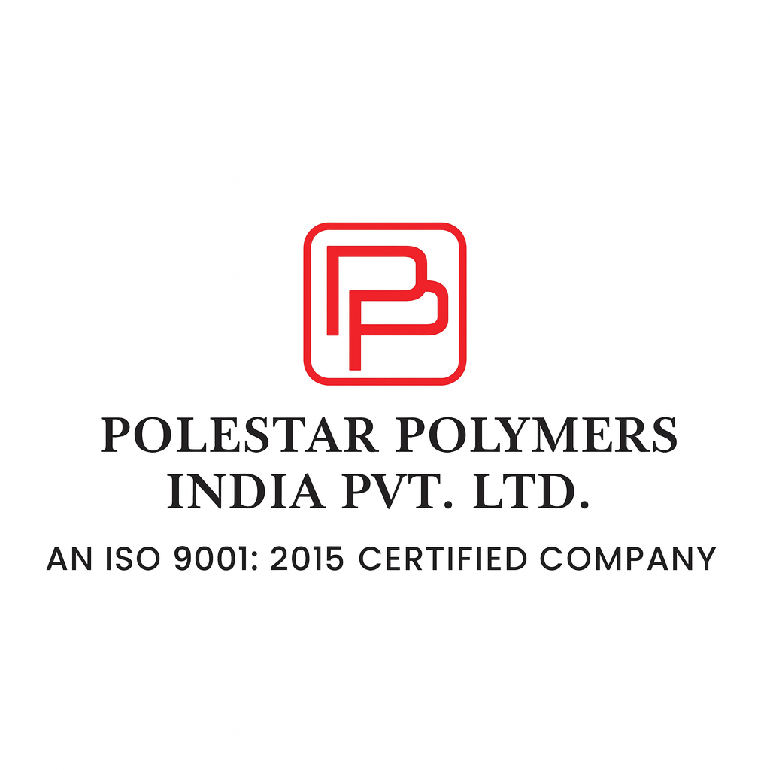.

Understanding HDPE Sheets and Their Importance
HDPE sheets are thermoplastic polymer sheets known for their high strength-to-density ratio. Compared to many conventional plastic materials, HDPE offers superior rigidity, impact resistance, and chemical stability.

Key Reasons Industries Prefer HDPE Sheets
- High tensile and compressive strength
- Lightweight yet extremely durable
- Excellent resistance to chemicals and moisture
- Easy to fabricate, machine, and weld
- Suitable for indoor and outdoor applications
These advantages make HDPE sheets a preferred solution in demanding industrial environments.
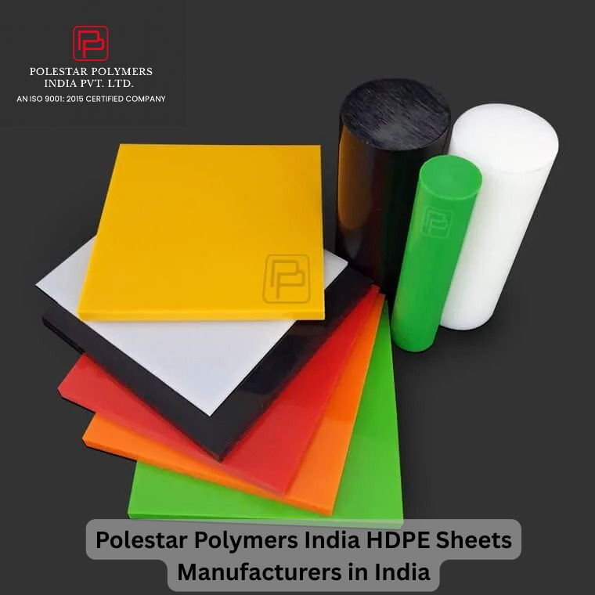

Growing Demand for HDPE Sheets in India
India’s rapid growth in manufacturing, infrastructure, food processing, and packaging sectors has led to an increased demand for reliable plastic materials. Industries are now actively looking for HDPE Sheets Manufacturers in India who can deliver consistent quality at scale.
Applications driving this demand include:
- Food processing equipment components
- Packaging and material handling solutions
- Engineering and machining components
- Chemical and industrial storage applications
As expectations rise, so does the need for manufacturers who understand both material science and real-world industrial use.
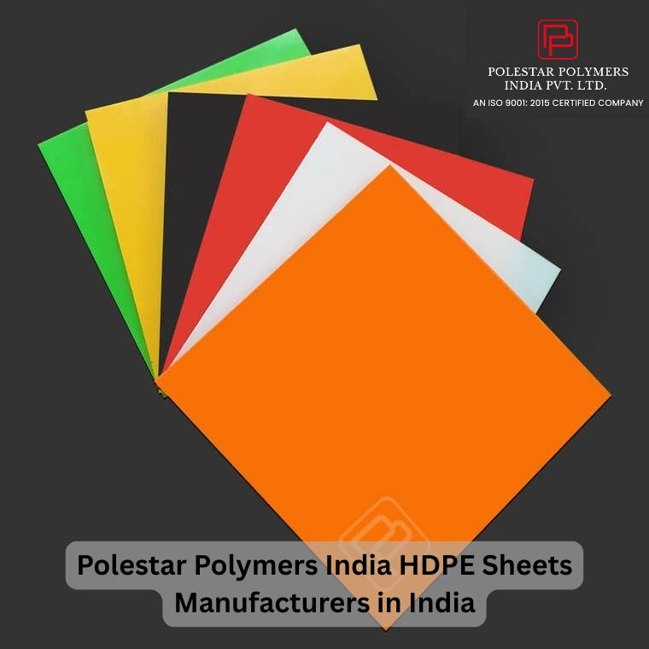

Introducing Polestar Polymers India Pvt. Ltd.
Polestar Polymers India Pvt. Ltd. is a well-established name in the Indian polymer industry, known for manufacturing high-quality HDPE sheets and rods under the brand STELLO E (HDPE).
With ISO 9001:2015 certification and advanced manufacturing facilities, Polestar Polymers focuses on delivering products that meet strict quality, performance, and durability standards.

What Makes Polestar Polymers a Trusted HDPE Sheets Manufacturer in India?

1. Consistent Material Quality
Polestar Polymers manufactures HDPE sheets using carefully selected raw materials and controlled production processes. This ensures:
- Uniform density
- Stable mechanical properties
- Long-term performance
Consistency is critical for industries where precision and reliability matter.

2. Wide Range of Sizes and Colours
HDPE sheets by Polestar Polymers are available in:
- Natural (white), black, and multiple colours
- Thickness ranging from 1mm to 100mm
- Widths up to 2000mm and lengths up to 4000mm
This flexibility allows customers to select exactly what their application demands.

3. Excellent Fabrication Properties
One of the biggest advantages of choosing Polestar Polymers is the ease of fabrication. Their HDPE sheets can be:
- Cut to size
- Machined precisely
- Welded or mechanically fastened
This makes them ideal for custom components and engineered solutions.
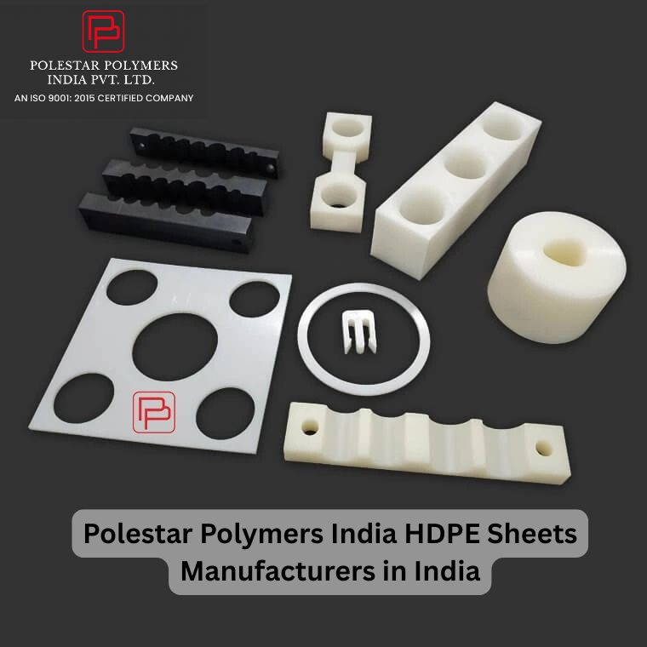

Characteristics of Polestar HDPE Sheets
Polestar HDPE sheets offer several performance benefits that set them apart:
- Minimal moisture absorption
- Lightweight structure
- Good electrical insulation
- Excellent chemical resistance
- High impact strength
- Easily weldable and machinable
These properties ensure reliable performance even in harsh industrial conditions.
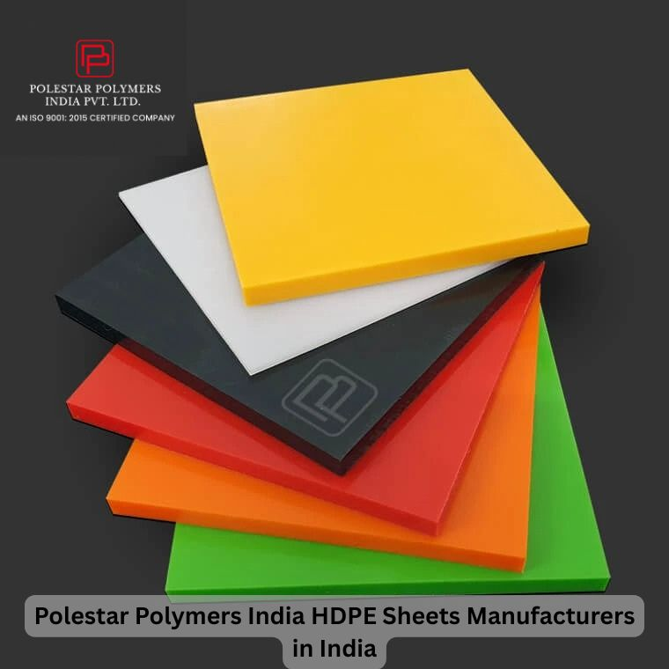

Typical Applications of HDPE Sheets
Polestar Polymers supplies HDPE sheets suitable for a wide range of applications, including:

✔ Food Industry Components
HDPE’s non-toxic and moisture-resistant nature makes it ideal for food processing environments.

✔ Sliding Profiles & Wear Strips
Low friction and high wear resistance make HDPE perfect for conveyor systems and guides.

✔ Plugs, Grips, and Packaging
Its toughness and flexibility support repeated use without cracking or deformation.

✔ Industrial Machined Parts
Polestar’s in-house machining facility enables precision-engineered HDPE components as per drawings.

In-House Machining – A Major Advantage
Unlike many generic suppliers, Polestar Polymers offers in-house machining facilities. This means customers can receive:
- Finished components
- Cut-to-size sheets
- Customized parts as per specifications
This capability saves time, reduces sourcing complexity, and ensures better quality control.

Why Choosing the Right HDPE Sheets Manufacturer Matters
Not all HDPE sheets perform the same. Poor-quality materials can lead to:
- Premature wear
- Dimensional instability
- Reduced safety
- Higher long-term costs
That’s why selecting a reliable HDPE Sheets Manufacturer in India is a crucial decision for any business.
Polestar Polymers focuses on long-term value, not short-term pricing.

Quality Assurance and Certifications
Polestar Polymers operates under strict quality systems and is ISO 9001:2015 certified, ensuring:
- Standardized production processes
- Continuous quality monitoring
- Reliable batch consistency
These practices build trust with customers across industries.

Customer-Centric Manufacturing Approach
What truly differentiates Polestar Polymers is its customer-first mindset. From enquiry to delivery, the focus remains on:
- Understanding application needs
- Offering suitable material recommendations
- Delivering consistent quality
- Supporting long-term partnerships
This approach has helped the company build a strong reputation across India.

Serving Industries Across India
Polestar Polymers supplies HDPE sheets to clients across multiple states, supporting:
- Manufacturing units
- OEMs
- Fabricators
- Industrial suppliers
Their ability to handle both bulk orders and customized requirements makes them a preferred partner.

Why Polestar Polymers Stands Out Among HDPE Sheets Manufacturers in India
Here’s what sets them apart:
- Specialized focus on polymer products
- Proven manufacturing expertise
- Wide product range
- In-house machining support
- Reliable delivery timelines
- Strong technical understanding
They don’t just sell HDPE sheets—they provide solutions that work in real-world conditions.

Long-Term Cost Benefits of Quality HDPE Sheets
Choosing high-quality HDPE sheets helps businesses:
- Reduce maintenance costs
- Increase component lifespan
- Improve operational efficiency
- Avoid frequent replacements
Polestar Polymers’ products are designed to deliver value over years, not just months.

Explore Premium HDPE Sheets by Polestar Polymers
If you are evaluating options among HDPE Sheets Manufacturers in India, Polestar Polymers India Pvt. Ltd. offers a proven combination of quality, reliability, and technical support.
View detailed product specifications and enquiry options here:
https://polestarpolymers.com/hdpe.html

Final Thoughts
HDPE sheets play a vital role in modern industrial applications. Choosing the right manufacturer can significantly impact performance, safety, and cost efficiency.
With advanced manufacturing, consistent quality, and customer-focused solutions, Polestar Polymers India Pvt. Ltd. has earned its position as one of the trusted HDPE Sheets Manufacturers in India.
