Weather Proof Outdoor Furniture: A Complete Buying Guide by Urbanland Products
Outdoor spaces are no longer just an extension of a building—they are places where people relax, socialize, and connect with nature. Whether it’s a garden, balcony, café, resort, or public seating area, the right furniture can transform any outdoor space. However, outdoor furniture faces constant exposure to sun, rain, dust, and changing temperatures. This is why investing in Weather Proof Outdoor Furniture is no longer optional—it’s essential. At Urbanland Products, we design outdoor furniture that blends durability, comfort, and modern style, making outdoor living practical and beautiful in every season.
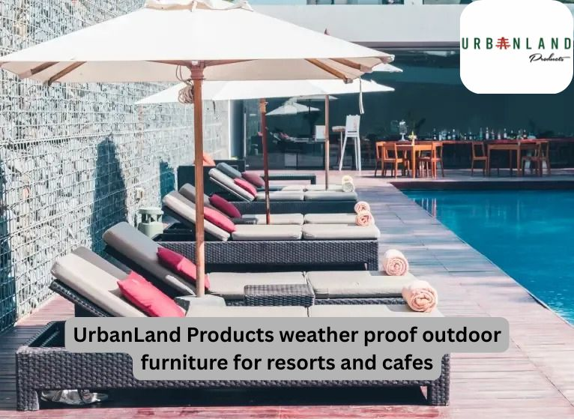

What Is Weather Proof Outdoor Furniture?
Weather proof outdoor furniture is specially designed to withstand harsh environmental conditions without losing strength, appearance, or comfort. Unlike regular furniture, it is built using materials and finishes that resist:
- Sun exposure and UV damage
- Rain and moisture
- Rust, corrosion, and fading
- Temperature fluctuations
This makes weather proof furniture ideal for long-term outdoor use with minimal maintenance.

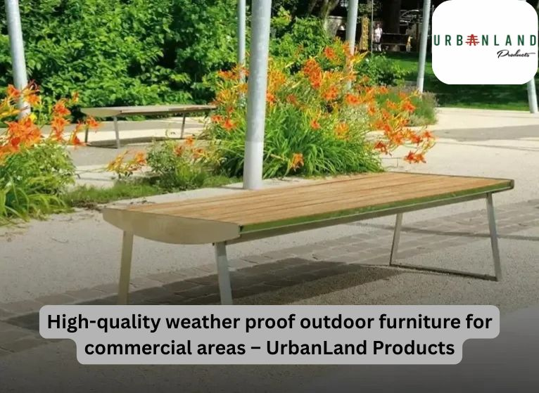

Why Weather Proof Outdoor Furniture Matters
Outdoor furniture is constantly exposed to the elements. Without proper protection, furniture can crack, rust, fade, or weaken over time. Choosing weather proof outdoor furniture ensures:

✔ Long-Term Durability
High-quality materials and protective coatings help furniture last for years, even in challenging climates.

✔ Low Maintenance
Weather proof furniture requires less cleaning, fewer repairs, and no frequent replacements.

✔ Cost Efficiency
Although the initial investment may be higher, the long lifespan reduces overall costs.

✔ Better Aesthetics
Furniture retains its finish, color, and structure, keeping outdoor spaces attractive year-round.
Urbanland Products focuses on all these aspects while designing its outdoor furniture collections.
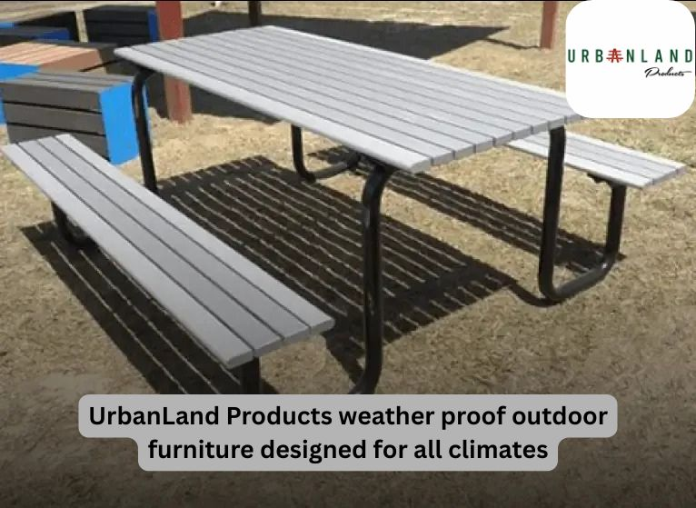

Popular Outdoor Spaces That Need Weather Proof Furniture
Weather proof outdoor furniture is suitable for a wide range of spaces:

✔ Gardens and Lawns
Benches, seating sets, and loungers that stay strong through sun and rain.

✔ Balconies and Terraces
Compact, stylish furniture that fits small spaces without compromising durability.

✔ Cafés and Restaurants
Furniture that handles heavy usage while maintaining appearance and comfort.

✔ Hotels and Resorts
Premium outdoor seating that enhances guest experience and complements luxury settings.

✔ Public Spaces and Parks
Strong, vandal-resistant furniture designed for long-term public use.
Urbanland Products designs solutions for both residential and commercial outdoor environments.

Best Materials Used in Weather Proof Outdoor Furniture
The durability of outdoor furniture largely depends on the materials used. Here are some of the most reliable options:

1. Aluminium Furniture
- Lightweight and rust-resistant
- Ideal for modern outdoor settings
- Easy to move and maintain

2. Powder-Coated Steel
- Strong and durable
- Excellent resistance to corrosion
- Suitable for public spaces, cafés, and parks

3. Treated Wood
- Naturally resistant to moisture and insects
- Adds warmth and elegance
- Ideal for gardens and resorts

4. Synthetic Rattan / Wicker
- UV-stabilized and weather-resistant
- Stylish and comfortable
- Perfect for lounges and poolside areas

5. Wrought Iron
- Extremely durable with protective coatings
- Ideal for traditional and decorative outdoor designs
At Urbanland Products, we carefully select materials that perform well in Indian weather conditions.

Maintenance Tips for Weather Proof Outdoor Furniture
Even the best furniture benefits from basic care. Here are a few simple tips:
- Clean regularly with mild soap and water
- Avoid harsh chemicals that may damage finishes
- Use covers during extreme weather for added protection
- Inspect fittings and fasteners periodically
Following these steps helps maintain the furniture’s appearance and performance over time.

Why Choose Urbanland Products?
At Urbanland Products, we specialize in creating weather proof outdoor furniture that meets real-world needs. Our approach focuses on:

✔ Durability
Built to withstand Indian climate conditions.

✔ Functional Design
Comfortable, ergonomic, and space-efficient.

✔ Premium Materials
High-quality metals, wood, and finishes.

✔ Versatile Applications
Suitable for homes, cafés, resorts, and public spaces.

✔ Modern Aesthetics
Designs that enhance the look of any outdoor area.
We don’t just manufacture furniture—we create outdoor solutions that last.

Weather Proof Outdoor Furniture for Indian Climate
India’s climate varies from intense heat to heavy monsoons. Furniture used outdoors must handle both extremes. Urbanland Products designs furniture that performs well across:
- Humid coastal regions
- Dust-prone urban environments
- Seasonal temperature changes
This makes our furniture a practical choice for long-term outdoor use.

Explore Weather Proof Outdoor Furniture by Urbanland Products
If you are planning to upgrade or design an outdoor space, choosing the right furniture makes all the difference.
👉 Read the complete guide and explore durable solutions here:
https://urbanlandproducts.com/weather-proof-outdoor-furniture-guide

Final Thoughts
Outdoor spaces deserve the same attention as indoor areas. With the right Weather Proof Outdoor Furniture, you can enjoy style, comfort, and durability without worrying about changing weather conditions.
Urbanland Products brings together smart design, premium materials, and long-lasting performance to help you create outdoor spaces that remain inviting all year round.

Stay Connected with UrbanLand Products:



