PVC Sheets Manufacturers in India: Why Polestar Polymers Is a Trusted Name for Quality & Reliability
When it comes to choosing the right PVC sheets manufacturers in India, buyers today are looking for more than just a supplier. They want consistency, quality assurance, customization options, and a company that truly understands application needs. From interior designers and signage companies to industrial buyers and fabricators, PVC sheets have become an essential material across industries.
India is home to many PVC sheet manufacturers, but only a few stand out for their commitment to quality, innovation, and customer satisfaction. One such trusted name is Polestar Polymers, a manufacturer known for delivering high-performance PVC sheets that meet modern industry demands.
In this blog, we’ll explore the growing demand for PVC sheets, their applications, what to look for in a manufacturer, and why Polestar Polymers is considered a reliable choice among PVC sheets manufacturers in India.
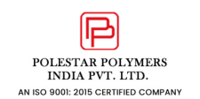

Growing Demand for PVC Sheets in India
PVC (Polyvinyl Chloride) sheets have gained massive popularity due to their versatility, durability, and cost-effectiveness. With rapid growth in construction, advertising, furniture, and industrial sectors, the demand for high-quality PVC sheets is increasing year after year.
Indian manufacturers now cater not only to domestic demand but also to global markets, supplying PVC sheets that comply with international quality standards. This growth has made competition stronger, pushing reliable manufacturers like Polestar Polymers to continuously upgrade technology and maintain consistent product quality.
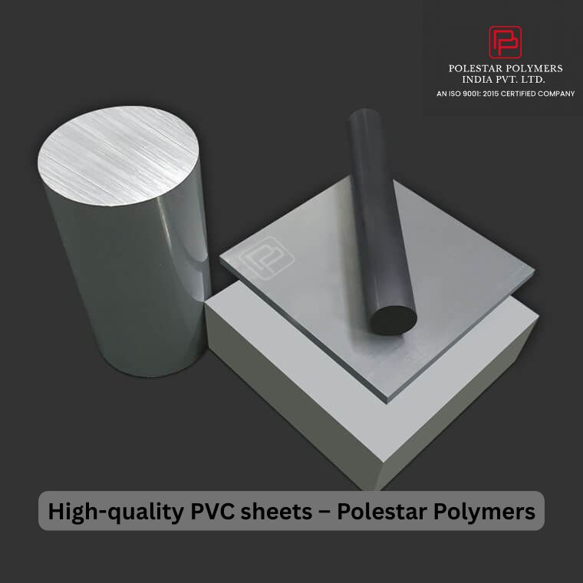

What Are PVC Sheets and Why Are They So Popular?
PVC sheets are lightweight, rigid or flexible plastic sheets known for their excellent resistance to moisture, chemicals, and corrosion. Their smooth surface, easy fabrication, and long lifespan make them a preferred alternative to traditional materials like wood and metal.

Key Benefits of PVC Sheets:
- High durability and strength
- Water and moisture resistance
- Excellent surface finish
- Easy to cut, bend, and fabricate
- Cost-effective and low maintenance
- Termite and corrosion resistant
These advantages explain why PVC sheets manufacturers in India are seeing rising demand across multiple industries.
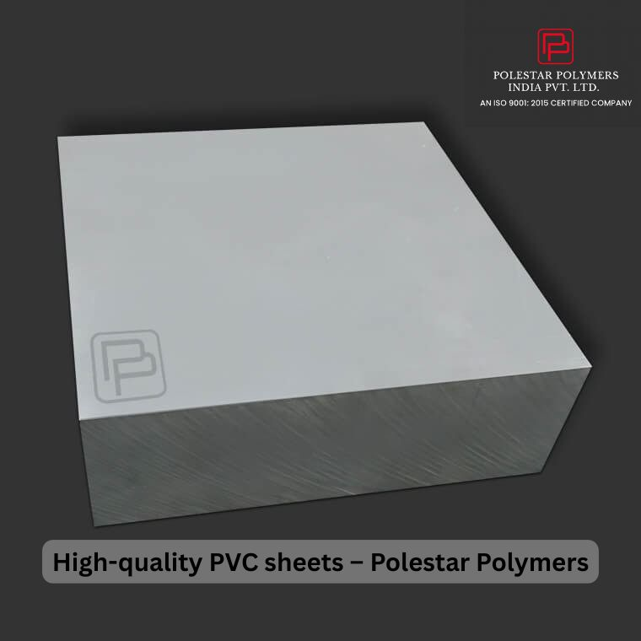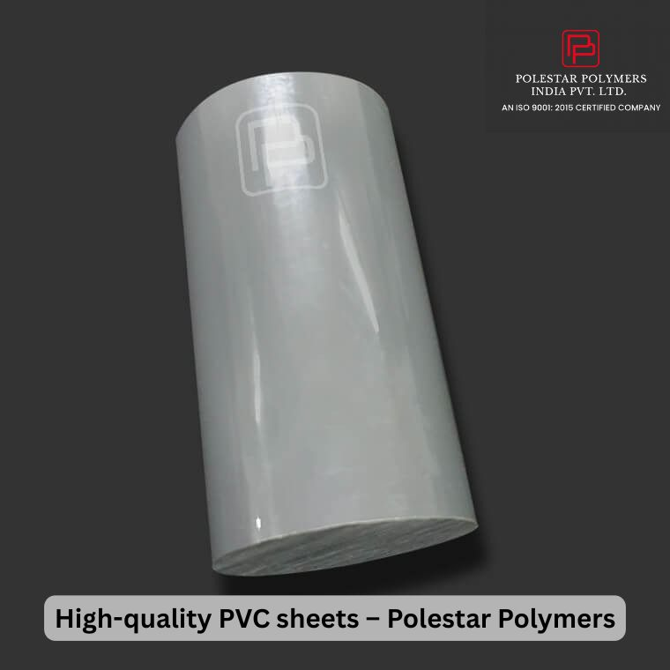

Major Applications of PVC Sheets
PVC sheets are incredibly versatile and used in a wide range of applications:

1. Interior & Furniture Industry
PVC sheets are widely used for modular furniture, cabinets, partitions, wall panels, and decorative interiors due to their clean finish and durability.

2. Signage & Advertising
From display boards to hoardings and digital printing backdrops, PVC sheets are a go-to choice for signage manufacturers.

3. Construction Sector
PVC sheets are used in cladding, false ceilings, insulation panels, and protective coverings.

4. Industrial Applications
Industries use PVC sheets for machine covers, chemical storage linings, electrical insulation, and fabrication needs.

5. Commercial & Retail Spaces
Retail displays, kiosks, and showroom interiors rely on PVC sheets for their aesthetic appeal and long-term performance.
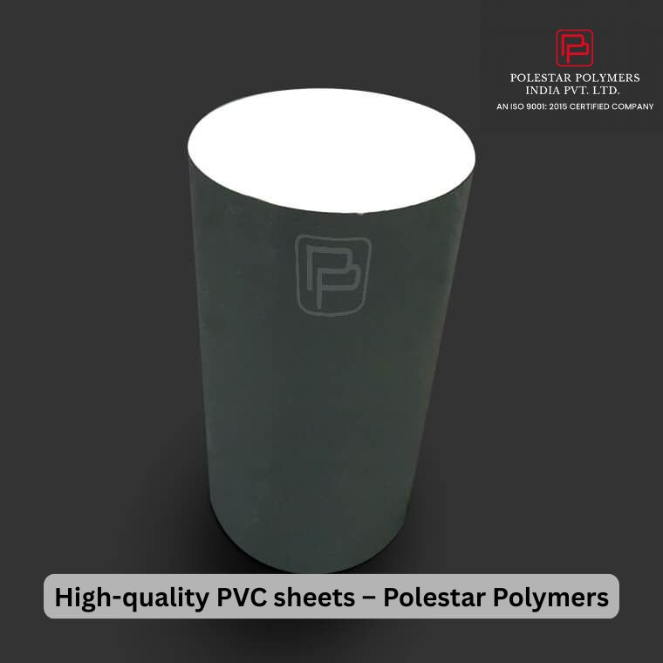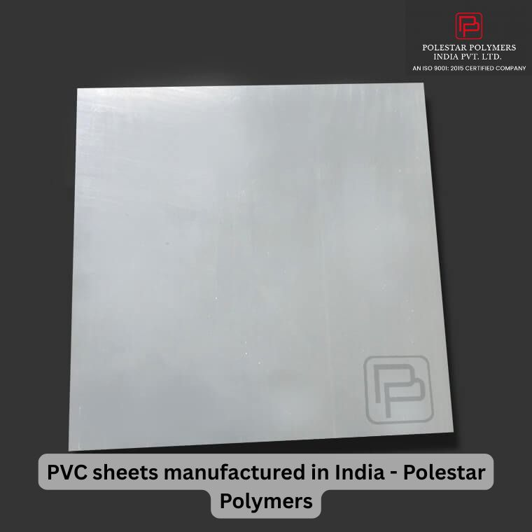

How to Choose the Right PVC Sheets Manufacturers in India
With so many options available, selecting the right manufacturer is critical. Here are some key factors buyers should consider:

Quality Standards
A reliable manufacturer follows strict quality control measures and uses premium raw materials to ensure consistent thickness, strength, and finish.

Manufacturing Capability
Advanced machinery and modern production processes ensure uniformity and scalability.

Customisation Options
The ability to offer customized sizes, thicknesses, and finishes is a big advantage.

Industry Experience
An experienced manufacturer understands application-specific requirements and can offer better technical support.

Timely Delivery & Support
Professional service, quick response times, and dependable logistics matter just as much as product quality.

Polestar Polymers: A Reliable Name Among PVC Sheets Manufacturers in India
Polestar Polymers has built a strong reputation as one of the dependable PVC sheets manufacturers in India, delivering products that combine performance, durability, and value.
With a focus on modern manufacturing practices and customer-centric solutions, Polestar Polymers serves a wide range of industries across the country.

What Makes Polestar Polymers Stand Out?

✔ Consistent Quality
Each PVC sheet is manufactured using high-grade raw materials and tested to ensure uniform thickness, smooth surface finish, and long-term durability.

✔ Advanced Manufacturing
Polestar Polymers uses efficient production techniques to meet bulk requirements without compromising quality.

✔ Wide Application Support
Whether you need PVC sheets for furniture, signage, interiors, or industrial use, Polestar Polymers provides solutions tailored to your needs.

✔ Customer-First Approach
The company focuses on understanding client requirements and delivering products that match expectations in both performance and pricing.

Why Businesses Trust Polestar Polymers for PVC Sheets
Many buyers prefer long-term partnerships over one-time purchases. This is where Polestar Polymers excels. Businesses trust the brand because of:
- Reliable product performance
- Transparent communication
- Competitive pricing
- Consistent supply
- Strong after-sales support
These factors have helped Polestar Polymers earn recognition as a dependable PVC sheets manufacturer in India.

Final Thoughts
The Indian market offers many options when it comes to PVC sheets manufacturers in India, but choosing the right partner can make a significant difference in quality, cost, and long-term performance.
Polestar Polymers stands out as a manufacturer that understands industry needs, delivers consistent quality, and builds trust through reliability and service. Whether you are a fabricator, interior designer, signage professional, or industrial buyer, partnering with a trusted manufacturer ensures peace of mind and better results.
👉 To explore PVC sheet specifications and applications, visit:
https://polestarpolymers.com/pvc.html

