Top Lab Solvent Storage Cabinet Manufacturers in Mumbai – Why RJ Lab Craft India Leads the Industry in 2025
When it comes to running a safe and efficient laboratory, one thing is absolutely non-negotiable - proper chemical storage. Whether you are managing a pharmaceutical lab, a school research facility, a biotech center, or an industrial testing unit, you need a dependable way to store solvents, reagents, acids, and hazardous chemicals without risking contamination, fire hazards, or exposure.
And this is exactly why the search for the Best Lab Solvent Storage Cabinet Manufacturers in Mumbai is more relevant today than ever.
Mumbai, being one of India’s biggest hubs for pharmaceuticals, healthcare, research, and industrial development, naturally attracts hundreds of labs that require high-quality solvent storage solutions. With increasing safety standards and compliance requirements, laboratories are now moving away from ordinary storage cupboards and investing in specialized solvent storage cabinets designed to prevent accidents and maintain hygiene.
In the middle of this growing demand, RJ Lab Craft India Pvt. Ltd. has emerged as a trusted, reliable, and innovative manufacturer of lab furniture and solvent storage cabinets in Mumbai. Their blend of quality materials, safety-driven designs, and customer-centric support has made them a preferred choice across industries.
This blog dives into everything you need to know:
✔ Why solvent storage cabinets are essential
✔ What features to look for
✔ Why Mumbai trusts RJ Lab Craft India Pvt. Ltd.
✔ How the company helps you upgrade your lab safety
✔ And why choosing the right manufacturer can save you from major risks


Why Every Laboratory Needs a Solvent Storage Cabinet
Many labs still make the mistake of storing chemical bottles on open shelves or inside basic wooden or metal cupboards. While it looks convenient, it comes with serious risks. Solvents are extremely sensitive—they evaporate, react quickly, and can easily ignite.
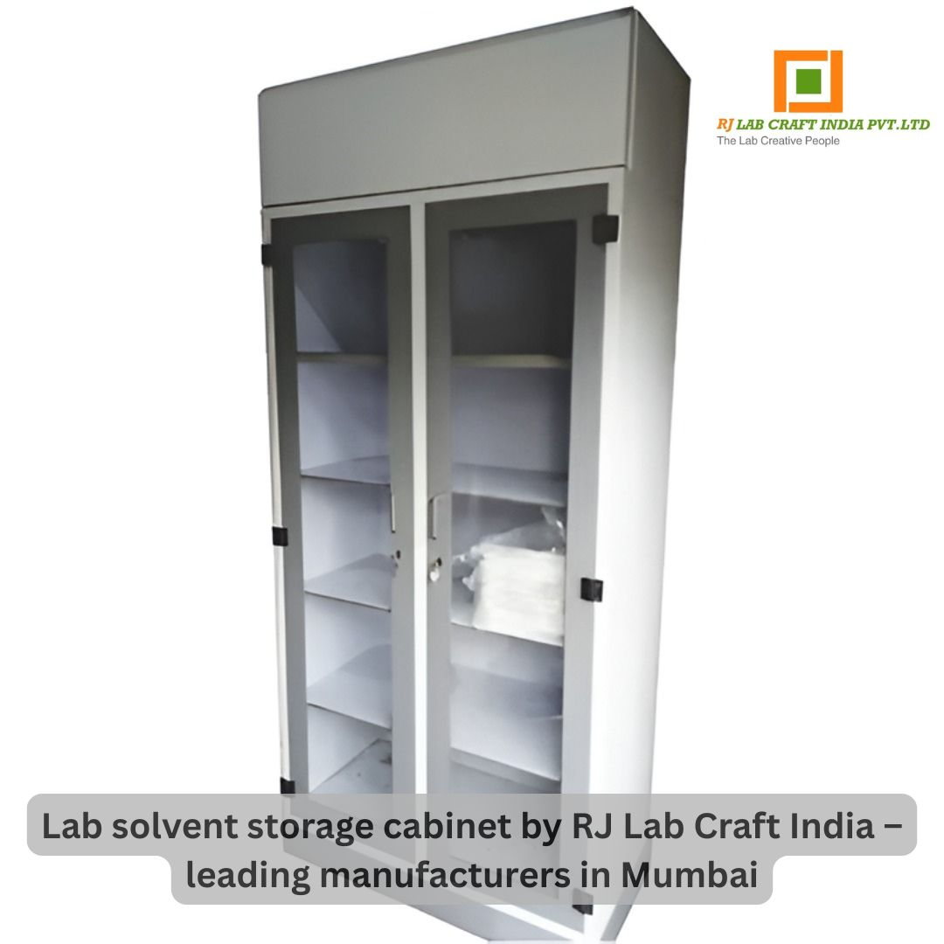
A solvent storage cabinet ensures:

1. Fire Protection
Most solvents are flammable. High-quality cabinets isolate them from heat sources and reduce fire risks.

2. Controlled Fume Emission
Even sealed bottles release fumes. Cabinets with proper ventilation ensure these fumes never enter your working space.

3. Spill Containment
If a bottle leaks or breaks, the cabinet’s spill-proof trays prevent chemical spread and contamination.

4. Organisation & Categorisation
Storing solvents properly reduces confusion and makes your workflow smoother.

5. Regulatory Compliance
Industry standards require chemical-compatible storage. A certified cabinet helps you meet lab safety norms.
A poorly chosen cabinet is just as risky as having no cabinet at all. That’s why working with trusted Lab Solvent Storage Cabinet Manufacturers in Mumbai matters—and RJ Lab Craft India Pvt. Ltd. is one of the best.

RJ Lab Craft India Pvt. Ltd. – Among the Top Lab Solvent Storage Cabinet Manufacturers in Mumbai
When you talk about quality, durability, and user-focused design in lab furniture, RJ Lab Craft India Pvt. Ltd. consistently stands out. The company is known for manufacturing modern, robust, and safety-compliant solvent storage cabinets used across:
- Pharmaceutical labs
- Educational institutes
- Chemical plants
- R&D centers
- Food laboratories
- Government testing facilities
- Industrial quality control labs
With every product designed according to safety guidelines, RJ Lab Craft India Pvt. Ltd. ensures your lab stays compliant, organised, and safe.
Explore their solvent cabinets here:
http://www.rjlabcraftindia.in/lab-chemical-storage-cupboard.php

What Makes RJ Lab Craft India Pvt. Ltd. a Trusted Name in Mumbai?

1. High-Quality Materials Tailored for Chemical Resistance
RJ Lab Craft uses materials such as stainless steel, MS powder-coated sheets, and chemical-resistant coatings to prevent corrosion, peeling, or reactions with stored solvents.

2. Strong Fire-Resistant Design
Their cabinets feature double-wall construction and fire-resistant finishes, making them ideal for flammable and hazardous materials.

3. Ventilation Options for Safe Fume Control
Custom venting systems ensure fumes stay contained and never escape into the working environment.

4. Spill-Proof Bottom Trays
In case of accidental leaks, chemical-resistant trays protect your workspace from contamination.

5. Adjustable Shelves
Their cabinets include adjustable, heavy-duty shelves to help you organise everything from small reagent bottles to larger solvent containers.

6. Modern and Aesthetic Finishes
While safety is the priority, the cabinets also enhance the overall look of your lab with clean, modern designs.

7. Years of Expertise in Lab Furniture
With deep industry experience, RJ Lab Craft understands real laboratory challenges and provides solutions that work.

8. Affordable Pricing with Excellent Durability
Their pricing is competitive without sacrificing quality—making them ideal for both established and budget-conscious labs.

A Closer Look at Their Lab Solvent Storage Cabinets
The cabinets offered by RJ Lab Craft India Pvt. Ltd. are carefully engineered to meet everyday lab demands. Some of the key specifications include:
- Material Options: SS304, MS powder-coated, GI sheet
- Noise-Free & Smooth Operation
- Corrosion-Resistant Build
- Durable Hinges and Locks
- Elegant Amplitude / Modern Finishes
- Multiple Size Options (small, medium, large)
- Fire-Resistant Coating
Their highly popular Lab Chemical Storage Cupboard is designed for safety, convenience, and long-term use.
Product details available here:
http://www.rjlabcraftindia.in/lab-chemical-storage-cupboard.php
How Lab Solvent Storage Cabinets Improve Lab Productivity
Choosing the right cabinet doesn’t just improve safety—it transforms how efficiently your lab operates.

✔ Safer Working Conditions
A controlled storage environment reduces respiratory exposure and fire risks.

✔ Better Organisation
Everything has a place, reducing clutter and improving workflow.

✔ Prevents Wastage & Damage
Chemical degradation is reduced when stored safely.

✔ Faster Audits & Inspections
Well-designed cabinets reflect professionalism and compliance.

✔ Peace of Mind
Your team can focus on work instead of worrying about accidental spills or leaks.

Why Choose a Mumbai-Based Manufacturer?
Mumbai is home to world-leading pharmaceutical and industrial facilities. Choosing a local manufacturer like RJ Lab Craft India Pvt. Ltd. ensures:
- Faster delivery
- On-site customisation
- Easy communication
- Quick service support
- Access to spare parts
- Seamless installation
This makes them one of the most dependable Lab Solvent Storage Cabinet Manufacturers in Mumbai.

Customisation: The Biggest Advantage
Every lab is different.
RJ Lab Craft India Pvt. Ltd. offers complete customisation including:
- Size adjustments
- Shelf arrangement
- Ventilation options
- Material selection
- Fire-safe coating levels
- Door design (single/double, glass/solid)
- Color coding for chemical categories
If your lab needs a custom-built solution, they’ll design one specifically for you.

What Customers Love About RJ Lab Craft India Pvt. Ltd.
Feedback from clients across Mumbai consistently highlights:

✔ Exceptional product durability
Cabinets last for years with minimal maintenance.

✔ Professional installation services
Their team handles everything smoothly.

✔ Transparent pricing
No hidden charges.

✔ Quick response time
Whether it’s inquiries or after-sales support, the team responds promptly.

✔ Clean, aesthetic, and modern cabinet designs
Labs look organised and visually appealing.

Conclusion: A Reliable Partner for Safer Laboratories
Finding the right Lab Solvent Storage Cabinet Manufacturers in Mumbai can feel overwhelming—but with RJ Lab Craft India Pvt. Ltd., the decision becomes easy.
Their combination of quality engineering, durable materials, customisation, and customer-first service makes them one of Mumbai’s top choices for:
- Solvent cabinets
- Chemical storage cupboards
- Lab furniture
- Laboratory safety solutions
If you want to upgrade your lab’s safety, improve efficiency, and invest in long-lasting storage, RJ Lab Craft India Pvt. Ltd. delivers the perfect blend of value, durability, and professional design.
👉 Explore their product here:
http://www.rjlabcraftindia.in/lab-chemical-storage-cupboard.php


