Glass Door Wall Cupboard Manufacturers in Mumbai – Why RJ Labcraft India Is the Trusted Choice
Modern laboratories demand more than just functional furniture. They require safe, organized, durable, and visually accessible storage solutions that support daily workflows without compromise. This is where Glass Door Wall Cupboards play a crucial role. If you are searching for reliable Glass Door Wall Cupboard Manufacturers in Mumbai, one name that consistently stands out is RJ Labcraft India.
Mumbai, being a hub for pharmaceutical companies, research labs, hospitals, diagnostic centers, and educational institutions, has a growing demand for high-quality laboratory furniture. In this blog, we’ll explore why glass door wall cupboards are essential, what to look for in a manufacturer, and why RJ Labcraft India is the preferred choice across industries.


Understanding Glass Door Wall Cupboards in Laboratories
Glass door wall cupboards are wall-mounted storage units designed specifically for laboratory environments. Unlike solid-door cabinets, these cupboards feature transparent glass panels that allow easy visibility of stored materials without opening the doors.
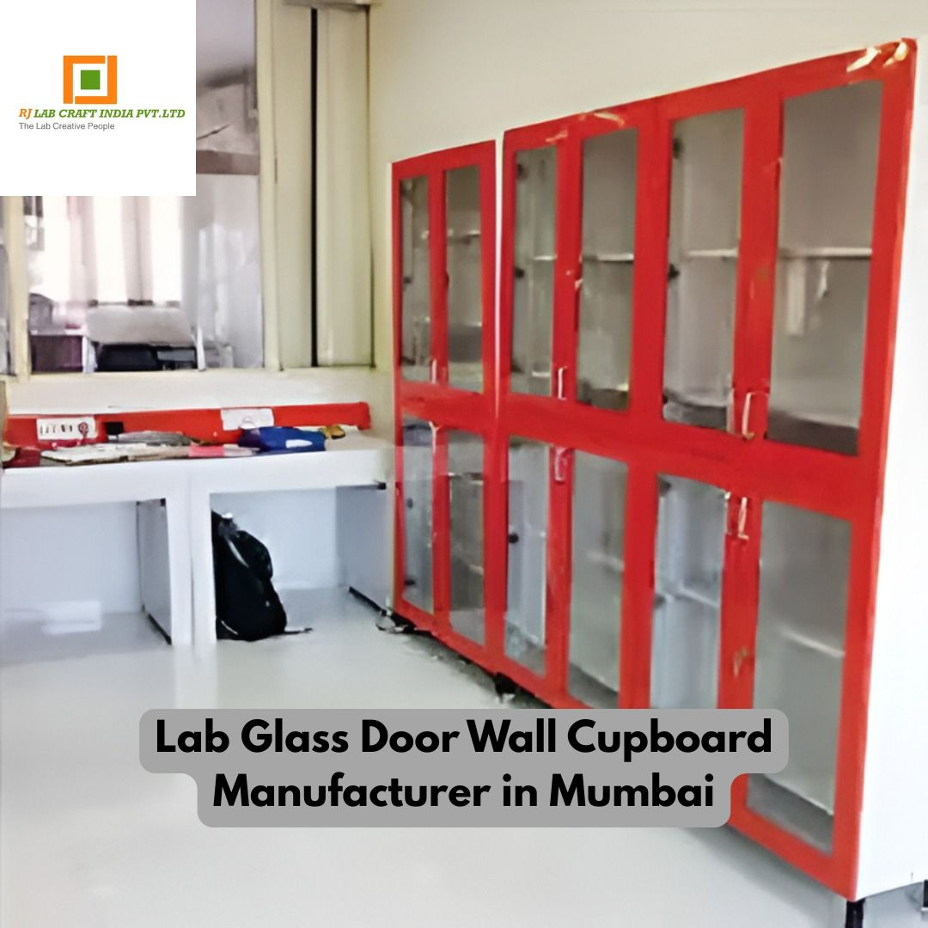

Why Laboratories Prefer Glass Door Wall Cupboards
- Quick visibility of contents
- Improved organization
- Reduced handling and contamination
- Modern and professional appearance
- Efficient space utilization
From chemical storage to lab equipment organization, glass door cupboards enhance workflow efficiency while maintaining safety standards.

Rising Demand for Glass Door Wall Cupboards in Mumbai
Mumbai’s industrial growth has led to a sharp rise in laboratory setups across sectors such as:
- Pharmaceuticals
- Biotechnology
- Chemical processing
- Healthcare & diagnostics
- Colleges and research institutes
With strict safety norms and operational efficiency requirements, laboratories increasingly seek trusted Glass Door Wall Cupboard Manufacturers in Mumbai who understand both design and compliance.

Why Choose RJ Labcraft India?
RJ Labcraft India is a well-established name in the laboratory furniture industry, known for delivering precision-engineered, durable, and customized lab storage solutions.

1. Industry-Focused Manufacturing
Unlike generic furniture suppliers, RJ Labcraft India specializes in laboratory-grade furniture, ensuring every glass door wall cupboard meets real-world lab requirements.

2. Premium Quality Materials
Each cupboard is manufactured using:
- High-grade mild steel or stainless steel
- Chemical-resistant coatings
- Toughened safety glass doors
- Smooth hinges and durable handles
This ensures long life even in demanding lab conditions.

Key Features of Glass Door Wall Cupboards by RJ Labcraft India

✔ Clear Glass Visibility
The transparent glass doors allow lab professionals to quickly locate chemicals, tools, or instruments without unnecessary opening, saving time and reducing exposure risks.

✔ Space-Saving Wall-Mounted Design
Ideal for labs with limited floor space, wall-mounted cupboards help keep workstations clutter-free and efficient.

✔ Easy Maintenance
The smooth surface finish and quality glass make cleaning simple, helping maintain hygiene and compliance standards.

Applications of Glass Door Wall Cupboards
RJ Labcraft India supplies glass door wall cupboards suitable for:
- Pharmaceutical Laboratories
- Chemical Testing Labs
- Research & Development Centers
- Educational Institutions
- Hospitals & Diagnostic Labs
- Industrial Quality Control Labs
Their versatile designs ensure compatibility across various lab environments.

What Makes a Good Glass Door Wall Cupboard Manufacturer in Mumbai?
When choosing from multiple Glass Door Wall Cupboard Manufacturers in Mumbai, it’s important to consider more than just price.

Important Factors to Evaluate:
- Manufacturing expertise in lab furniture
- Use of lab-grade materials
- Customization options
- Safety and durability standards
- After-sales support
- Timely delivery
RJ Labcraft India checks all these boxes, making them a dependable partner for both small and large-scale lab projects.

Safety & Compliance Standards
Laboratory furniture must comply with strict safety norms. RJ Labcraft India designs cupboards that support:
- Safe chemical storage
- Reduced risk of spills
- Secure door locking options
- Proper load-bearing capacity
This attention to safety is why many labs prefer RJ Labcraft India over general furniture manufacturers.

Why Mumbai Clients Trust RJ Labcraft India
Mumbai-based clients value:
- Local manufacturing support
- Quick response times
- Understanding of regional compliance needs
- On-time project execution
RJ Labcraft India has built long-term relationships by consistently delivering on these expectations.

Long-Term Cost Efficiency
While quality lab furniture may seem like an investment upfront, it saves money in the long run through:
- Reduced maintenance
- Longer lifespan
- Improved workflow efficiency
- Lower replacement costs
RJ Labcraft India focuses on value-driven manufacturing, ensuring you get durable products without unnecessary expense.

How Glass Door Wall Cupboards Improve Lab Efficiency
- Faster access to materials
- Better inventory visibility
- Cleaner workspaces
- Enhanced professional appearance
- Reduced operational delays
These small improvements add up to significant productivity gains over time.

Why RJ Labcraft India Stands Out Among Competitors
What truly differentiates RJ Labcraft India from other Glass Door Wall Cupboard Manufacturers in Mumbai is their customer-first approach. From consultation to installation, their focus remains on delivering practical, reliable, and future-ready lab solutions.

Final Thoughts
Glass door wall cupboards are no longer optional—they are an essential component of modern laboratories. When quality, safety, customization, and long-term performance matter, RJ Labcraft India emerges as a trusted name among Glass Door Wall Cupboard Manufacturers in Mumbai.
👉 Explore detailed product specifications and solutions here:
https://www.rjlabcraftindia.in/glass-door-lab-wall-cupboard.php


