Top BOPP Tape Adhesive Manufacturer in India: Why SKS Finechem Leads the Market in 2025
In today’s fast-moving packaging and logistics world, one product that quietly holds everything together is BOPP tape adhesive. Whether it’s e-commerce shipping, FMCG packaging, industrial sealing, warehousing, or retail—BOPP adhesive tapes are everywhere. But what truly decides the quality of these tapes is the adhesive behind them. That’s where choosing the right BOPP Tape Adhesive Manufacturer in India becomes essential.
Among many players in the chemical and adhesive industry, SKS Finechem has built a strong reputation for delivering high-performance, reliable, and industry-approved adhesive solutions. Their BOPP tape adhesive products stand out not only for consistency and quality but also for their suitability across multiple applications.
You can explore their BOPP adhesive product here: sksfinechem.com/bopp.php
This blog will walk you through everything you need to know—what BOPP tape adhesive is, why SKS Finechem is a trusted manufacturer, key features of their adhesive, industry applications, and how businesses benefit from choosing the right supplier.


What Exactly Is BOPP Tape Adhesive?
BOPP (Biaxially Oriented Polypropylene) tapes rely on a special adhesive coating that binds firmly to cardboard, corrugated boxes, plastic surfaces, and various packaging materials. The adhesive is the “soul” of the tape—it defines how well the tape sticks, how long it lasts, and how it performs under stress.
A high-quality BOPP tape adhesive must deliver:
- Strong grab (initial tack)
- Long-term adhesion
- Heat and cold resistance
- Smooth application
- Durability during storage and transit
This is why selecting a trusted BOPP Tape Adhesive Manufacturer in India is crucial for packaging companies, distributors, and brands aiming for consistent packaging performance.
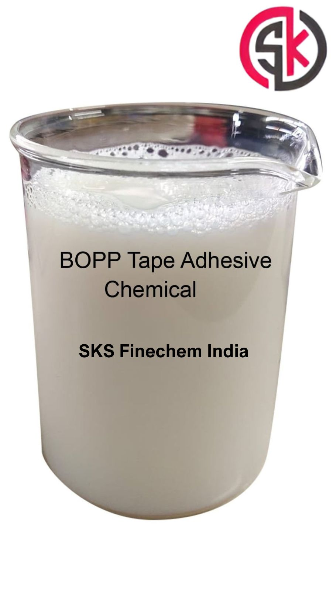

Why SKS Finechem Leads as a BOPP Tape Adhesive Manufacturer in India
SKS Finechem has emerged as a reliable name across India’s adhesive and chemical industry due to its quality-first approach, updated manufacturing processes, and customer-centric product development. Their BOPP tape adhesive is crafted to meet the demands of fast-paced industries that require consistency and long-duration hold.
Here’s what makes them stand out:

✔ Top-Grade Raw Materials
SKS Finechem uses high-purity raw materials, ensuring a stable and smooth adhesive coating that doesn’t clump, crack, or weaken over time.

✔ Advanced Manufacturing Technology
Their production line is built with modern adhesive-processing technology that ensures uniformity and performance consistency in every batch.

✔ High Bond Strength
The adhesive provides strong initial stickiness and long-term durability, even in challenging packaging environments.

✔ Temperature Resistance
From humid climates to cold storage environments—SKS Finechem’s adhesive maintains its performance.

✔ Excellent Film Wetting & Coatability
The adhesive spreads smoothly and evenly on BOPP film, ensuring proper coating without defects.

✔ Customization for Industries
SKS Finechem understands that every packaging setup is different. They offer tailored adhesive formulations for:
- E-commerce packaging
- Heavy-duty industrial packing
- FMCG & retail packaging
- Logistics and courier operations

Key Features of SKS Finechem’s BOPP Tape Adhesive

1. Strong Adhesion Power
Perfect for carton sealing and heavy-duty packaging.

2. Fast Drying
Makes production faster and effortless for tape manufacturers.

3. High Transparency
Allows smooth coating and ensures clear tape quality.

4. Long Shelf Life
Adhesive retains performance even after months of storage.

5. Environmentally Conscious Formulation
Low VOC levels and eco-friendly manufacturing processes.
These features make SKS Finechem a preferred BOPP Tape Adhesive Manufacturer in India for brands seeking reliability and performance.

Industries Using BOPP Tape Adhesive from SKS Finechem
Because BOPP tape is universally used, SKS Finechem’s adhesive serves a wide range of industries:

● Packaging & Logistics
E-commerce companies depend on strong BOPP tapes for safe shipping.

● Manufacturing & Industrial Operations
Factories requiring long-term box sealing choose high-tack adhesive.

● Food & Beverage
Seals lightweight and medium-weight cartons securely.

● Textile & Garment
Used in both packaging and internal material handling.

● Retail & FMCG
Ensures clean, tamper-proof packaging.
The versatility of SKS Finechem’s adhesive makes it a preferred choice across India.

Why Choosing the Right Manufacturer Matters
A tape is only as good as its adhesive. Low-quality adhesives lead to:
- Tape peeling off
- Carton breakage during transit
- Customer complaints
- Extra packaging costs
- Branding loss due to poor packaging quality
Choosing a reliable BOPP Tape Adhesive Manufacturer in India like SKS Finechem ensures:
- Reduced wastage
- Cost-efficient tape production
- Better brand reputation
- Stronger, safer packaging
For any packaging-dependent business, this decision directly affects operational success.

How SKS Finechem Ensures Quality

✔ In-House Testing Labs
Every adhesive batch undergoes rigorous testing for tack, viscosity, peel strength, and temperature resistance.

✔ Skilled Team of Chemists & Engineers
Experts ensure formulations stay consistent and updated with industry needs.

✔ Strict Quality Control
No batch is dispatched without passing performance benchmarks.

✔ Customer Feedback Integration
They continuously evolve formulations based on real industrial feedback.
This makes SKS Finechem not just a manufacturer but a long-term industry partner.

Who Should Buy BOPP Tape Adhesive from SKS Finechem?
SKS Finechem is ideal for:
- BOPP tape manufacturers
- Industrial packaging suppliers
- E-commerce packaging vendors
- Corrugated box manufacturers
- Large-scale warehouses and packers
- FMCG packaging units
Their adhesive solutions are built for both small businesses and large-scale production units.

Why SKS Finechem Offers Better Value

1. Consistency You Can Trust
Every batch performs reliably.

2. Affordable Pricing
Competitive rates without compromising quality.

3. Technical Support
Expert guidance for optimal usage and application.

4. Supply Reliability
Timely delivery and uninterrupted availability.
This strong value mix makes SKS Finechem one of the most trusted BOPP Tape Adhesive Manufacturers in India today.

Final Thoughts: Choose SKS Finechem for High-Quality BOPP Tape Adhesive
If your business relies on packaging, choosing a trusted adhesive manufacturer is not optional—it’s essential. SKS Finechem stands out with its commitment to quality, reliable service, and advanced adhesive formulations designed specifically for Indian industrial requirements.
Explore their complete product details here: sksfinechem.com/bopp.php

