Stainless Steel Elbow 90 Degree Manufacturer in India: Why Kemlite Piping Solutions Is a Trusted Industry Name
In any piping system, even the smallest component plays a critical role. Among these, the stainless steel elbow 90 degree fitting is essential for changing the direction of flow while maintaining strength and efficiency. For industries searching for a reliable Stainless Steel Elbow 90 Degree Manufacturer in India, quality, precision, and long-term performance are top priorities.
India has become a global hub for stainless steel pipe fittings, supplying products to industries worldwide. Among the manufacturers leading this space, Kemlite Piping Solutions stands out for its consistent quality, modern manufacturing, and customer-focused approach.
In this blog, we’ll explore the importance of stainless steel 90 degree elbows, their applications, what to look for in a manufacturer, and why Kemlite Piping Solutions is trusted by buyers across industries.
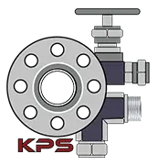

What Is a Stainless Steel Elbow 90 Degree?
A stainless steel 90 degree elbow is a pipe fitting used to change the direction of flow by 90 degrees in a piping system. It is commonly used where space constraints or system design require a sharp turn.
These elbows are manufactured in various:
- Sizes and diameters
- Wall thicknesses (schedule-wise)
- Seamless and welded forms
- Long radius (LR) and short radius (SR) types
Because they are exposed to pressure, temperature, and flow stress, manufacturing quality is crucial.
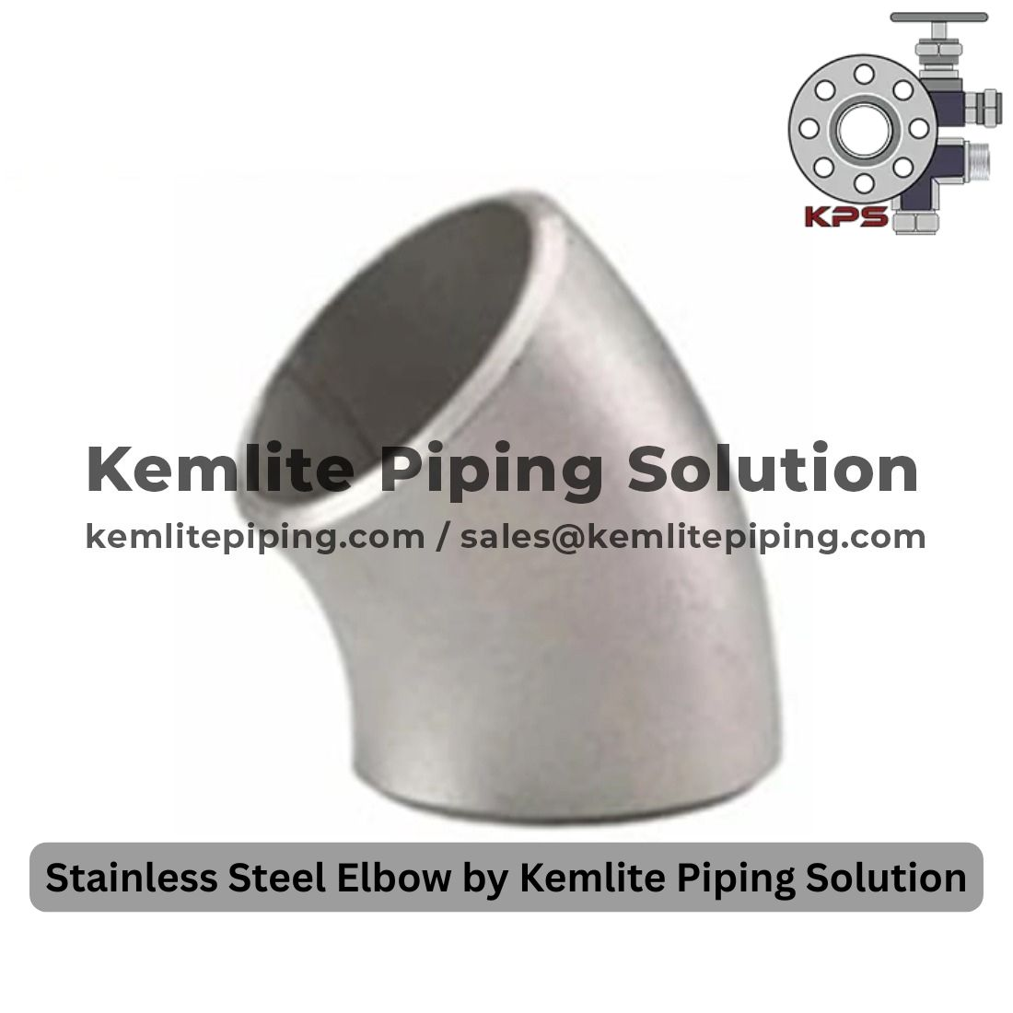

Why Stainless Steel Is Preferred for 90 Degree Elbows
Stainless steel offers excellent mechanical and chemical properties, making it ideal for piping fittings.

Key Benefits:
- High corrosion resistance
- Excellent strength and durability
- Withstands high pressure and temperature
- Smooth internal surface for better flow
- Long service life with low maintenance
These advantages make stainless steel elbows suitable for both standard and extreme applications.

Growing Demand for Stainless Steel Elbow 90 Degree Manufacturers in India
The growth of oil & gas, chemical processing, power plants, construction, and infrastructure projects has increased demand for stainless steel pipe fittings. Global buyers increasingly rely on Indian manufacturers for quality products at competitive prices.
This demand has highlighted the importance of choosing a reliable Stainless Steel Elbow 90 Degree Manufacturer in India who can meet international standards and supply requirements.
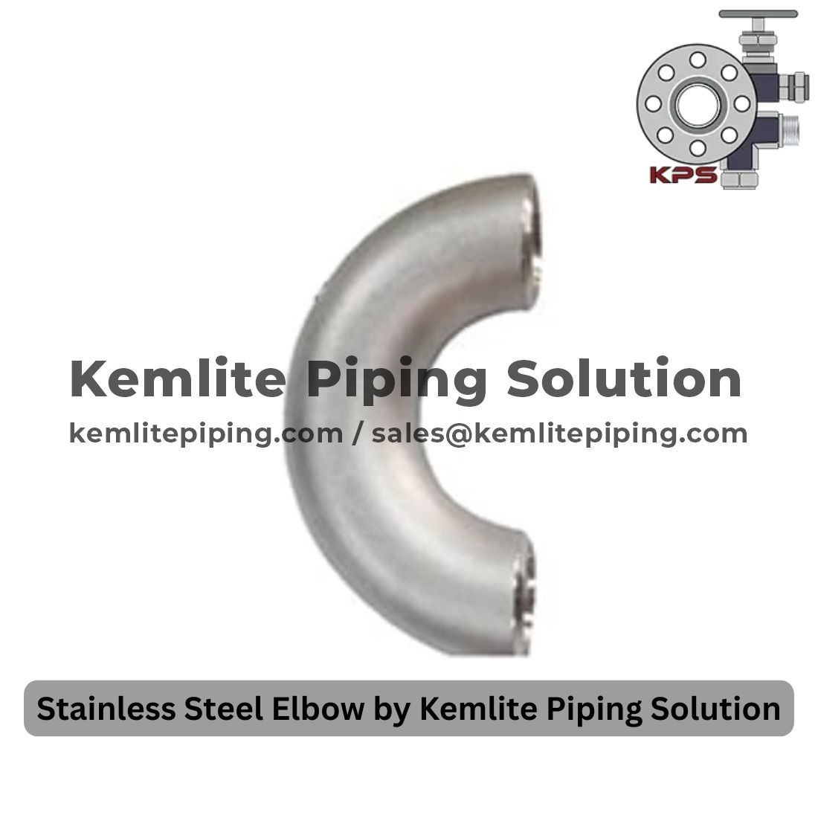

Applications of Stainless Steel 90 Degree Elbows
Stainless steel 90 degree elbows are widely used across industries:

1. Oil & Gas Industry
Used in refineries, pipelines, and offshore installations.

2. Chemical & Petrochemical Plants
Ideal for corrosive and high-temperature environments.

3. Power Generation
Used in thermal, nuclear, and renewable power systems.

4. Water Treatment & Plumbing
Ensures clean and safe fluid transport.

5. Food, Beverage & Pharmaceutical
Maintains hygiene and prevents contamination.
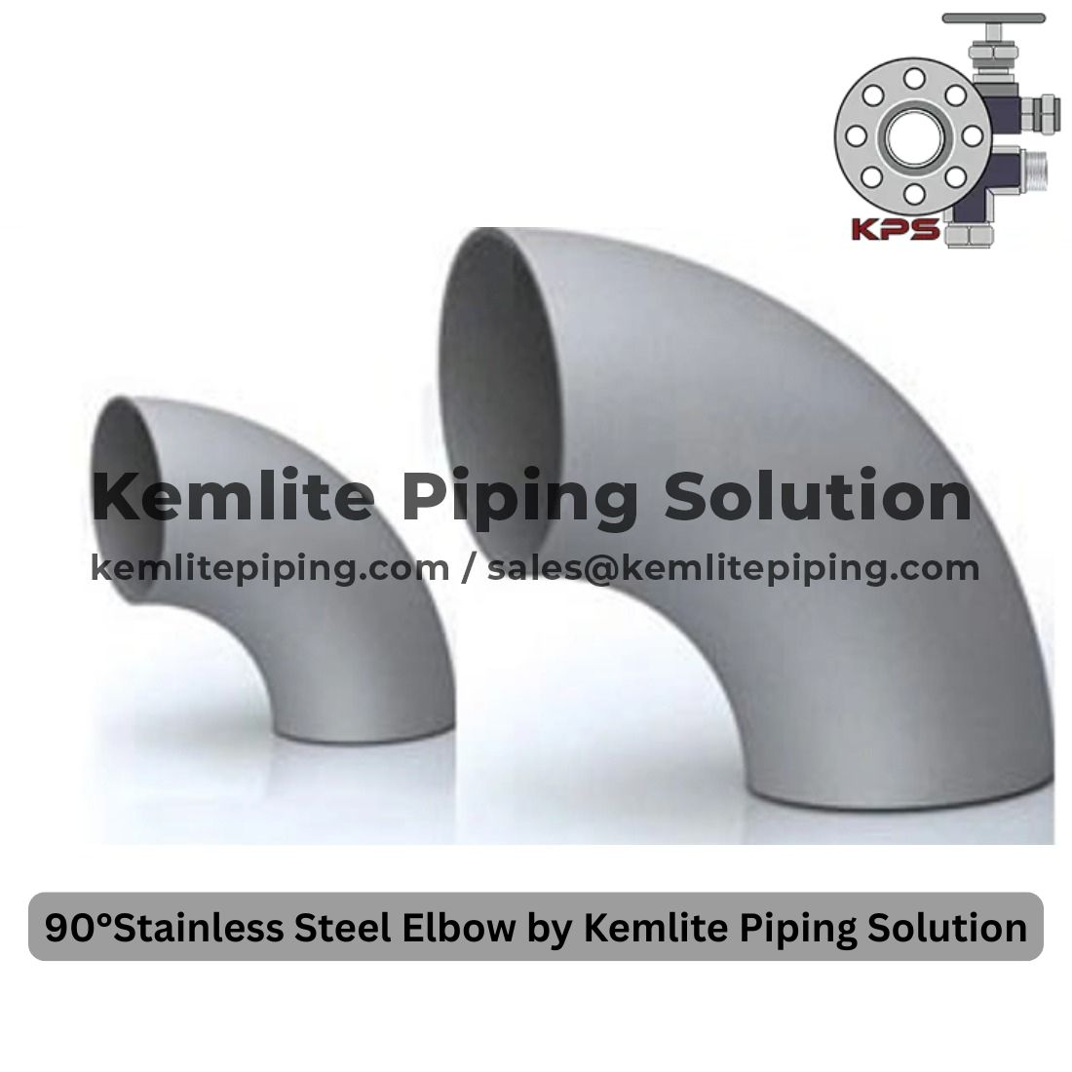

How to Choose the Right Stainless Steel Elbow Manufacturer in India
Selecting the right manufacturer ensures system safety and longevity.

Factors to Consider:
- Material grade options (304, 316, 321, etc.)
- Precision manufacturing & dimensional accuracy
- Compliance with ASTM, ASME, and other standards
- Quality testing and inspection procedures
- Ability to supply bulk and custom orders

Kemlite Piping Solutions: A Reliable Stainless Steel Elbow 90 Degree Manufacturer in India
Kemlite Piping Solutions is a trusted manufacturer and supplier of stainless steel pipe fittings, including 45°, 90°, and 180° elbows. The company is known for delivering high-quality products that meet both domestic and international requirements.
With a strong focus on precision engineering and quality control, Kemlite Piping Solutions has become a preferred choice for industries worldwide.

What Makes Kemlite Piping Solutions Stand Out?

✔ Superior Manufacturing Quality
Each stainless steel elbow is manufactured using high-grade raw materials and advanced processes.

✔ Wide Product Range
Kemlite offers elbows in multiple sizes, schedules, and specifications to suit diverse applications.

✔ Strict Quality Control
Products undergo rigorous inspection to ensure strength, finish, and dimensional accuracy.

✔ Export-Ready Capabilities
Kemlite Piping Solutions serves both Indian and international clients with reliable logistics support.

✔ Customer-Centric Approach
Timely delivery, transparent communication, and technical support build long-term partnerships.

Quality Standards & Testing
A reliable stainless steel elbow 90 degree manufacturer in India follows strict quality standards. Kemlite Piping Solutions emphasizes testing such as:
- Chemical analysis
- Dimensional checks
- Visual inspection
- Pressure and hardness testing
This ensures every product performs reliably in real-world conditions.

Why Indian Manufacturers Are Preferred Globally
Indian stainless steel fitting manufacturers are globally recognized due to:
- Competitive pricing
- Skilled workforce
- Modern production facilities
- Compliance with international standards
Kemlite Piping Solutions combines all these strengths, making it a dependable partner for global buyers.
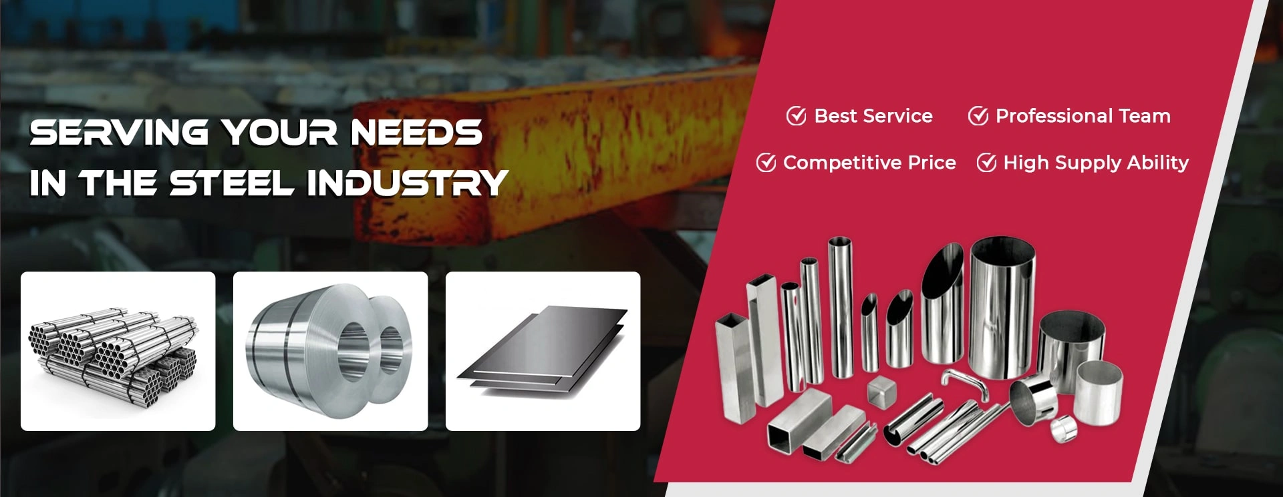

Final Thoughts
Choosing the right Stainless Steel Elbow 90 Degree Manufacturer in India is essential for building safe, efficient, and durable piping systems. Quality fittings reduce maintenance, improve flow efficiency, and enhance system reliability.
Kemlite Piping Solutions continues to be a trusted name in stainless steel pipe fittings, offering precision-engineered 90 degree elbows that meet the demands of modern industries.
👉 Explore stainless steel elbows here:
https://www.kemlitepiping.com/elbow-45-90-180-degree.php

