Eyeglasses in Canberra: Clear Vision, Comfort, and Style for Everyday Life
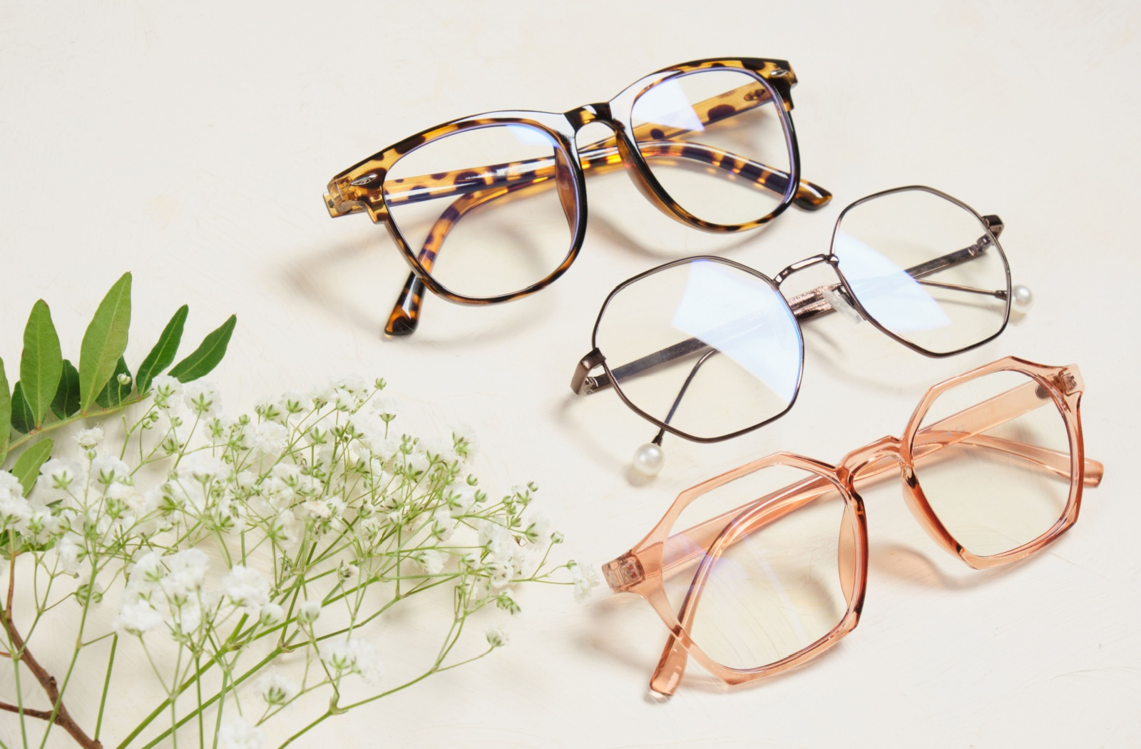
Eyeglasses are more than just a vision correction tool—they are an essential part of daily life that supports comfort, productivity, and eye health. For individuals seeking reliable eyeglasses in Canberra, choosing the right combination of lenses and frames is key to achieving clear vision and long-term comfort. With modern optical advancements, eyeglasses today are designed to meet both functional and lifestyle needs.

Why Quality Eyeglasses Matter
Wearing poorly fitted or outdated glasses can lead to eye strain, headaches, and reduced visual clarity. High-quality eyeglasses are carefully crafted to match your prescription while considering how you use your eyes throughout the day—whether for reading, screen work, driving, or outdoor activities.
Professional optical services ensure that lenses are accurately centered, frames fit securely, and vision correction is precise. This attention to detail plays a major role in maintaining eye comfort and reducing fatigue.

Prescription Glasses in Canberra: Tailored to Your Vision
When it comes to prescription glasses in Canberra, personalization is essential. Every prescription is unique, and lenses must be selected based on factors such as prescription strength, eye health, and lifestyle habits. Options include single-vision lenses for distance or reading, bifocals for multiple focal points, and progressive lenses that provide seamless vision at all distances.
Modern prescription lenses can also include advanced coatings, such as anti-reflective treatments to reduce glare, blue light filters for digital screen use, and scratch-resistant layers for durability. These enhancements improve both visual clarity and everyday usability.

Choosing the Right Frames
Frames are not just about appearance—they directly affect how well your glasses perform. Properly chosen frames ensure lenses sit correctly in front of your eyes, providing accurate vision correction. A good frame should feel comfortable, stay in place, and suit your face shape.
For those exploring eyeglasses in Canberra, there is a wide variety of frame styles available, from classic designs to contemporary looks. Lightweight materials, flexible hinges, and durable construction help ensure long-lasting comfort and reliability.

Eyeglasses for Every Lifestyle
Different lifestyles demand different eyewear solutions. Office professionals may benefit from lenses designed for prolonged screen use, while drivers may require enhanced clarity and reduced glare. Students, seniors, and outdoor enthusiasts all have unique visual needs that can be addressed through customized eyeglasses.
Prescription glasses can also be paired with prescription sunglasses, offering UV protection while maintaining clear vision outdoors. This is especially important in bright conditions, helping to protect eyes from sun-related damage.

Professional Eye Care Makes the Difference
Accurate eye testing is the foundation of effective eyewear. Regular eye examinations help detect changes in vision early and ensure prescriptions remain up to date. Optometry professionals guide patients through lens and frame selection, ensuring eyewear solutions align with both vision needs and personal preferences.
At Junic Eye Care, patients can explore a wide range of eyewear options designed to combine clarity, comfort, and style.

Invest in Long-Term Vision Health
Choosing the right prescription glasses in Canberra is an investment in long-term eye health and daily comfort. With professional guidance, modern lens technology, and well-fitted frames, eyeglasses can enhance both vision and confidence.
Whether you need new eyeglasses or an updated prescription, prioritizing quality eye care ensures your vision is supported at every stage of life.

